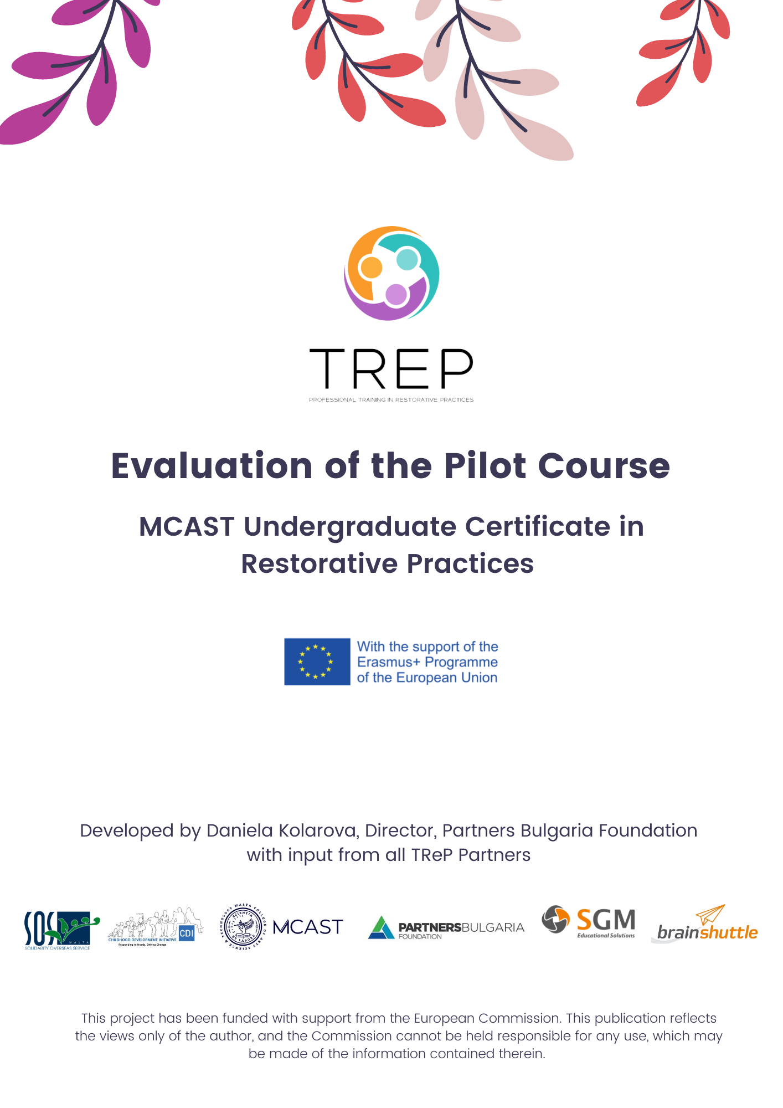

**Introduction**

The pilot of the ‘MCAST Undergraduate Certificate in Restorative Practices’, a European accredited Level 5 Course, started in January 2021 and was successfully completed in November 2021. Evaluation was ongoing throughout the duration of the course through the integration of an online questionnaire following each unit. Live tutorials were also used to gather student feedback as well as direct communication with tutors and course administrators.

**Objective**

The objective of the evaluation is to identify the strengths and challenges of the pilot course and to make changes in the digital learning platform where it is necessary, to ensure that the final course design and materials offers learners throughout Europe a high quality, relevant and easy to use course.

**Methodology**

The methodology consists of quantitative and qualitative data collection. A questionnaire was made available to course participants at the end of each unit. The questionnaire included two sets of questions related to:

1. Content i.e., i) Course expectations; ii) Course content; and iii) Knowledge assessment.
2. Design i.e., iv) Timing; v) Pace and navigation; vi) Platform design; vii) Video and other visual materials; viii) Interactive learning and ix) Overall satisfaction.

**Participants**

As mentioned above, the questionnaire was distributed to all course participants at the end of each unit. The number of respondents varied with each unit - the course commenced in January 2021 with 34 participants and was completed in October 2021 with 18 applicants.

Table 1. *The table below indicates the number of respondents to the questionnaire. The number in brackets showcases the actual number of students following the course at the time of evaluation.*

|  |  |  |  |  |  |
| --- | --- | --- | --- | --- | --- |
| **Country of Origin** | **Unit 1** | **Unit 2** | **Unit 3** | **Unit 4** | **Unit 5** |
| **Malta** | 7 | 5 | 5 | 6 | 5 (6) |
| **Ireland** | 13 (+1)[1] | 10 | 9 (+1) | 9 | 7 (9) |
| **Bulgaria** | 3 | 1 (+1) | 0 | 0 | 0 |
| **Germany** | 2 | 2 | 2 | 2 | 2 |
| **Romania/Spain** | 1 | 1 | 0 (+1) | 1 | 1 |
| **UK** | 1 | 0 | 0 | 0 | 0 |
| **Total** | 27 (28) | 19 (20) | 16 (18) | 18 (18) | 15 (18) |

The progress of participants from different countries is shown in Table 1, above.

Among the 18 participants, who completed Unit 5 and the course, are students from Malta (6), Ireland (9), Spain/Romania (1) and Germany (2).

All course participants, who filled the questionnaire, provided their name and email address.

**Summary of Findings**

**Strengths**

1. The satisfaction rating for the course was high overall. The 18 participants who completed the course found the course to be both useful and inspiring; they also demonstrated progress in their knowledge and skills in RP.
2. Course content was presented in a comprehensible manner and almost all participants expressed a high level of understanding.
3. Most participants perceived the content in all modules to be consistent and relevant. Participants found the content to be informative and interesting; they also expressed praise for the variety in types of materials offered - from videos to reading materials. Throughout the evaluation phase the content and the examples presented were rated as either good or high quality.
4. Among the most useful and interesting parts mentioned by participants in each Unitwere case studies, videos, podcasts, talks, RP theorists, practical references and examples.
5. The legibility of text and fonts, the quality of video and audio materials and the visual design including the images and graphics used were rated as rather satisfactory or completely satisfactory.
6. Tutorials were evaluated as very successful, useful, informative and inspiring. Their value was related not only to information sharing but also to group bonding and social-emotional learning.
7. The establishment and operation of Peer Practice Groups was evaluated as a highly useful and successful element of the Course.

**Challenges**

1. The content was presented with a satisfactory level of clarity and logic but the presentation of the data could be improved further.
2. The volume of information was found to be too extensive and overwhelming given the time constraints as well as given the EQC level of the course (EQC Level 5 Undergraduate). Some students found the content to be quite complex and difficult to absorb within the course framework.
3. Repetition of information was also perceived as an issue as it demanded more time without the added value of learning something new.
4. Most students found the relevance of the assignments satisfactory; a few, however, found the assignments to be “completely relevant”.
5. The issues related to the navigation of the e-learning portal were consistent throughout the course. Instructions related to platform navigation would have been useful in the form of short videos or infographics at the beginning of the course.
6. Language barrier challenges were reported as a persistent issue as well, and in fact this was one of the main reasons the pilot study experienced several drop-outs – even though participants had the minimum level required they still found it difficult to assimilate the data in a second language.

**Recommendations**

**Creation of Course Booklet**

In the near future it may be opportune to develop a course booklet that could be made available to participants beyond their period of study. Furthemore, an official publication containing the course information, may be considered by the course authors in the future.

**Content Validity**

The content of the course would need to be adapted and kept up-to-date in order to remain aligned with any changes in the global and local contexts.

**Live Tutorials**

Now that the course is beyond Pilot Stage it will become a part of the MCAST official course list for the next 3 years. In order to sustain this and facilitate the live tutorials it would be ideal to develop in-house capacity to oversee this aspect of the course. Other viable local options are learners in the pilot course from Malta who successfully graduated in November 2021. This could be approached incrementally, offering a shadow learning option, whereby a CDI tutor would pair up with a potential MCAST / local tutor in order for the latter to shadow and learn from the former - a form of Training the Trainer. Once local tutors have gained enough training and experience, their knowledge can then be cascaded internally at MCAST through CPD workshops, hence expanding and capitalizing on in-house resources.

**Assessment**

It would be useful to optimize the volume of assessment tasks and reduce these to two; for example, one multiple choice questionnaire and an assignment of 1000 words. This recommendation will be investigated further in order to identify the assessment method most suited to measure learning acquisition while meeting time restraints.

**Evaluation of the Course**

The evaluation method adopted throughout the pilot study proved to be very detailed and useful. Moving forward the same method of evaluation could be adopted. However, it need not be as detailed as the questionnaires distributed during the pilot study. Official course participants will only be asked to provide feedback on the learning process related to each Unit.

**Prevention of Drop-Outs**

The pilot course has shown that the level of English required by participants needs to be set higher in order to ensure that the participants are able to cope with the reading material the course has to offer. Relevant education and former experience are also important. In addition, basic technical skills are required as well. Other factors that should be considered in order to prevent high numbers on drop-outs would be to set realistic expectations with regard to the intensity of the coure and the time required to complete it. It is strongly recommended that this course be offered for completion over a minimum of 18 months.

**Support**

As mentioned in previous sections, the course content as well as the time-frames imposed can be perceived as quite taxing to some participants. As such, it was suggested to implement a ‘support mechanism’ or a ‘buddy system’ in order to serve as a point of reference throughout the learning process. This should also include a brief induction on Moodle in order to pre-empt any navigational issue the users might have on the platform.

**Unit 1**

1. **Understanding the Content**

Participants have been asked to rate their understanding of contents of Unit 1 using a scale from 1 (did not understand at all), to 5 (completely understood). The results showed that there was a high level of understanding of the content of Unit 1: 70.4 % of course participants completely understood the content of the course; 11.1% understood it almost completely. Only 18.5% (5 participants) ticked the middle circle showing that they had certain difficulties in understanding the content.

1. **Consistency and Relevance**

Participants were asked to rate the consistency and relevance of the lesson learning material in relation to the Unit 1 Learning Outcomes. They used a scale from 1 (not consistent and relevant at all) to 5 (completely consistent and relevant). Most of the learners, 55.6%, reported that they found the material completely consistent and relevant; another large part of the group, 33.3%, found the material rather consistent and relevant; 7.4 % (2 learners) found the material in the middle of the extreme opinions, while 1 person (3.7%) thought that the material was rather inconsistent.

1. **Quality of the Content and the Examples Presented**

Overall, positive feedback was received for the quality of the content of learning materials and the examples presented: 50.3% found the material to be of excellent quality; 25.9% - evaluated the material as very good. A small percentage of learners evaluated the material between excellent and poor (11.1%) or as neither excellent, not poor; only one person thought that the material was not that good (3.7%).

1. **Likes and Dislikes**

When asked about the specific examples of what was liked or disliked about 1. the content presented and 2. In the examples given, most participants expressed satisfaction and shared a lot of positive experiences.

They liked the excellent content, felt it was clearly outlined, and found the examples to be informative, in fact these were described as *“clear and to the point, helping to understand lesson’s content”*. Other people enjoyed the quiz or the TED talks, which they described as a nice break from reading.

Many participants underlined that the great mix of resources facilitated the learning. They liked the different mediums presented and real-life case studies. The content was of high quality, interesting and relevant to life.

*“Content was of excellent quality, a varied representation of how RP can be used. “*

*“I like that it was clearly outlined and explained in an interactive way, that gave a sound background to the whole subject, especially the historical background, which I didn't know about.”*

*“I liked the given examples.”*

*“I thought all the materials were very interesting and motivational.”*

*“I like how it was a mix of media, videos, podcasts and articles.”*

*“I really liked the practical examples and the windows (social discipline and relationship).”*

Some of the dislikes were related to the repetition of content, even though other participants found the repetition helpful to better understand the key concepts of RP. For the latter group, the repetition served to help integrate all information as they learnt.

The main complaints were related to time consumption and the serious efforts needed to complete Unit 1. Others found the content not clear enough and that an overview of the content of each section was missing.

“*There was a lot of content and some of it a little bit repetitive but it enhanced my understanding further”;*

*“One or two of the articles I felt were very repetitive of what we have learned already in the unit lesson.”*

*“I did find that there were a lot of questions to be answered, and took up a lot of time, more than expected. As a slow reader who doesn't read and type too well on screen, it was physically taxing having to print, write and re-type everything, especially given the whole hiccup about things not being saved, that physically hurt me.”*

*“I did not like it: the large volume of tasks (articles, questions) in a limited time; several assessments for the unit - for example Ass. 1, Ass.2, Short narrative, Long narrative. All this is very stressful!”*

Other dislikes were related to the specific parts of the content:

*“I disliked the part "Magnificent 7" at Restorative Practices in Various Context.”*

1. **Most Useful and Interesting Parts of Unit 1**

A lot of learners pointed out that the content was very interesting and useful, including the examples, TED talks and the reference to practice. They listed various parts of the Unit 1 to be useful:

* Reading how RP is used in different countries, especially the history of the ancient civilizations.
* Different Models of Restorative Conflict Resolution and application examples.
* The RP theorists particularly Kay Pranis and Margaret Thorsborne.
* The journals were found to be very informative and relevant to the sections that they were included in.
* The evolution of the models.
* Learning more about the social discipline window and the relationship window.
* Restorative Practices Theorists
* TED talks were very interesting and informative.

*“I found it interesting that self-care, rest and reflecting is so important. The case study about Black and Latino students in America was very interesting”.*

*“I found the Case Studies very interesting of people who use RP on a daily basis.”*

*“The practical part and studies of cases, applying the different windows and the quiz. I loved them. That 8 question quiz made me fully understand the difference between TO, NOT, FOR, WITH and as well the RW with SDW.”*

*“I though the evolution of the social discipline window to the relationship window was great.”*

*“How RP can be applied in a variety example and a detailed outline specifically in workplaces, schools and communities.”*

1. **Least Useful and Interesting Parts of Unit 1**

The question *“What part of Unit 1 did you find least useful and interesting?”* received 27 responses but quite a few did not give any answer or noted N/A (not applicable) as they did not have anything to say. Many participants noted that all parts had their own importance: *“I found it all fascinating”, “It was all useful.”*

Still, many of them noted some personal issues with different parts of the content.

One learner said that she did not like the summarizing of papers that had to be read: *“I understand needing to read the content and making sure it is done, but it caused such pressure to read and highlight on my printed work and then find a way of paraphrasing, which this content could have been easily assessed in the assessment.”*

Another one did not like the content related to the Evolution of Social Discipline Window – she found that it was too much information and quite complex. Other learners mentioned they did not find the Restorative Practices in Various Contexts, Restorative Practices Theorists or the history of PR *(“I personally have never liked history”).*

People were a bit overwhelmed by the volume of information:

*“The history part... so many names to remember as theorist, countries and years where it started, how it evolved”.*

*“I was a little overawed by the historical part, partly because of the volume of information and partly because I didn't understand how the course was laid out.”*

*“It was all very useful however there is definitely some literature which was repetitive and not necessary.”*

*“There was some repetitive reading on some topics”*

*“Reading different articles which repeated the same information”.*

*“Some of the readings were hard to engage with.. just the academic style of writing”*

Other complains was related to the origin of the information:

*“Most readings were based on US culture”*

There were people who had problems with the platform:

*“I found using the Moodle platform very difficult.”*

*“Unfortunately it is the constant going back in and re-entry as the system keeps logging out”.*

1. **Clarity & Logic**

The question *“Was the content of Unit 1 arranged in a clear and logical way? Tick only one circle?”* was answered in a positive manner with the following nuances: 37% of participants found the content completely clear and logical; 37% found the content rather clear and logical; and 25.9% found it in between clear and unclear. The results indicated that there was room for improvement in relation to the content organisation and clarity of its presentation.

1. **Relevance of Assignments**

Most participants found the assignments completely relevant (40.7%) or rather relevant (25.9%), while 33.3% evaluated the assignments between relevant and irrelevant.

1. **Timing**

Course participants have been asked *“Was the amount of time it took to complete Unit 1 appropriate? Why or why not?”*. The answers showed that learners had unrealistic expectations that the course would be less time consuming. Most of the participants stated that Unit 1 took too long.

For one participant it took too long because of issues on how to use the platform. *“The losing of all the work done, made me loose a full 3 days of work all in one go and that was a massive deal.”*

*“It took quite an amount of time due to technical issues and having to re-do sections but after Tutorial 3 expectations became clearer and IT issues were resolved.”*

Another reason was related to the volume of the content that required careful reading and understanding. *“Ït needed a lot of time especially having a slower pace and less time due to work constraints on how to work on the course.”*

The timing of the life tutorial was found to be too late for effective learning. *“The live tutorials are way too late!!!! 7:30 - 9:30 Malta time, please do them a little earlier!”*

The common complaint was that there was too much content to cover in such a short period of time. People spent more time than it was allocated, and some found difficulty to meet the time schedule because of the volume of the content. In addition, time was especially inappropriate for those who struggled with the foreign language.

*“Time was not appropriate. There is too much to read, listen to, and not enough time. 90 mins is not enough to read, think and write”.*

*“The number of hours required to complete Unit 1 was very high. 20 hours a week if very difficult when working, it is higher than any post graduate course I have taken in the past.”*

*“No. I found it very time consuming due to trying to manage work commitments and learning commitments. But I also am aware that there has to be demands and expectations in this course also”.*

*“The time was short. It should be noted that most students are working in a language that is not their mother language by origin.”*

*“I am engaged in other work so I found it impossible to finish on time.”*

*“I found it takes up too much time.”*

*“In my opinion the time limit for questions was the least appropriate.”*

*“I felt that the assessments, even though timed, could be reattempted or done on a document and uploaded so we could research the answers. A short time could be added on, to allow researching answers as part of the assessment. It would result in better time management and a more accurate view of the attendees understanding of the topic.”*

*“I think the time frame planned to cover the topics, especially when reading papers and analyzing videos, was a little bit unrealistic.”*

*“The intensity of the knowledge base is much higher than a level 5”.*

*“It was way too time consuming as progress was lost due to a technical problem and there were a lot of pages to read.”*

*“I believe 90 minutes was allocated to each topic for completion and I found it took me a lot longer than this, particularly the first session we had to complete independently.”*

Along with complaints about the timing there were participants who expressed understanding of the course management and the necessity to devote proper learning time.

*“It took long but as the responsible teachers told that this was what was expected, it was ok - more information about the content and time frames before the course starts”.*

*“30 days is a reasonable time I believe, considering that we are grown up adults with many obligations, work, children, housing, etc. but I considered it "my time"- as I decided to study RP for myself and if I would have the chance to work as RP in a school / orphanage or prison”.*

1. **Topics Not Covered**

Most students found that the content was rich enough and no additional topics were suggested to fill it.

*“I think what was covered was extensive.”*

*“An awful lot was covered already, so nothing more to suggest”.*

A few suggestions were related to more information about the RP in other cultures and the relationship window vs the social discipline window. RP use in prisons was suggested as well because there were more examples about schools.

A student wanted to have recommended books for additional reading. Another one wanted more guidance related to the use of the Moodle platform and the Assessment.

**Platform Design**

1. **Understanding the Moodle Platform**

For many participants the Moodle platform was a challenge. Only 11.1% (3) participants did not have problems understanding how to operate with the Moodle platform, while the rest had difficulties. One learner (3.7%) said it was not easy at all to understand the platform and other 6 (22.9%) found the platform rather uneasy to understand.

1. **Ease of Navigation Through Different Features**

The above difficulty was confirmed when the learners were asked to rate the ease of navigation of different features of Moodle platform. Again, only 11.1% (3) participants had no problems navigating the platform features, all the rest were facing various difficulties with one quarter of the participants (25.9%) finding the platform rather difficult or very difficult to navigate.

1. **Visual Design**

When asked to rate the overall visual design, including the images and graphics used in Unit 1, 48.1% of learners rated it as completely satisfactory; 33.3% - as satisfactory; 14.8% had rated their answer in the middle between unsatisfactory and completely satisfactory and only one said that the visual design was rather unsatisfactory.

1. **Legibility**

The legibility of text and fonts in Unit 1 were rated positively: 51.9% rated it as completely legible; 29.6% rated it as rather legible and only 18.5% said it was between legible and illegible. No one rated the text and the font as illegible.

1. **Quality of Video and Audio Material**

Majority of participants in the course evaluated the quality of video and audio materials as being with excellent quality (66.7%) and good quality (18.5%). Only 4 learners had lower rates to the quality of presented video and audio materials.

1. **Examples About the Good and Bad Qualities of the Moodle Platform**

Learners have been asked “Please provide any specific examples about what you liked or did not like about a) the Moodle platform and b) the images, video and audio materials presented.” Here are some answers and issues shared by learners:

* Difficulty to find what they need

*“It is a little disjointed for me to find what I need, and sometimes I can't find my content! Once in the lesson I like the content and it is very fun.”*

* Save function did not work

*“The answers would not save!”*

*“It is just the constant pain of being constantly logged out - you can't see what has been saved so you have to save everything on a word document and keep re-entering. It would also be helpful to distinguish what was important and what was for my own notes. I spent a lot of time doing detailed responses when there was no need. I was then fed up by the first assessments and felt very stressed to have timed exams without warning. I have since learnt that I can take my time to answer the assessments without panic.”*

*“The way that Moodle says you have completed something and does not save this and says you haven't completed it make it difficult to be positive about it. It is very frustrating.”*

This issue was corrected during the course of Unit 1 so participants expressed satisfaction that it worked after the technical amendments in the platform.

*“Moodle was a bit strange regarding the auto save feature of your work. I lost my work a number of times. However, this was resolved and l could use the system much more efficiently.”*

*“I've used the Moodle platform before so I knew to save my work on separate docs/ pdf s but it can be frustrating when work isn't saved.. some guidance would have been handy.”*

* No spell check and word count functionalities

*“No option to check word count in the text boxes and a lot of research had to be done to figure out how to incorporate spell check into the word boxes.”*

* Font style and size

*“The font style is difficult to read and the size is quite small”.*

*“The boxes for writing should enlarge”.*

* Difficulty moving between sections

*“I needed to leave the window and go through the sections to find out where I last finished.”*

*“It just took me a while to manoeuvre my way around Moodle initially but after a while was able to figure it out.”*

*“Having to move backwards and forwards between sections was difficult”.*

* Time consuming to get used to the platform and lack of introduction to Moodle

*“There should have been a introduction. Getting to know Moodle took quite some time off of the time for the actual class.”*

* Video materials with not very clear audio

*“In some of the audio materials, the voice was not clear.”*

*The work typed or done in the platform was difficult to see.*

*“I couldn't see my work as I was typing onto the platform, except for one or two sentences; e.g.on the final question below I can only see 8 words at a time! Then when I was using word, I had to save it as a PDF before attaching it. Why not copy and paste? My adult children, who are much more familiar with online learning, have suggested other platforms such as Brightspace are much easier to use.”*

*“Moodle drove me crazy. It got stuck several times, my answers started to vanish, I could not figure out navigating back to previous pages.”*

*“Moodle in the first classes was difficult to follow, I wasn ́t sure where I am; regarding assessments I wasn ́t sure I must write on each question minimum 200/300/1000 etc. words, or in general, or only at the first question*.”

* Lack of possibility to download the materials

*“I wish I could download the audio to my phone so I could listen over and over to it while driving; as well as the reading material would have been so helpful to have them; as well in audio format so we could listen to them while driving (my vision is not the best, so I can get easily foggy and tired vision after reading a number of pages).”*

*“I found programme used for the independent sessions good, however, there is no way to print the information provided. Difficulties also arose with saving my answers to questions posed and also difficulties with my answers populating when I tried to print the learning journal.”*

1. **Tutorials**

The question “*Were the Unit 1 Tutorials useful to you? Why or Why not?”* was answered in a very positive way.

Course participants found the tutorial content very relevant to their learning. The tutorials were instrumental for learners to get an orientation in the course content and the substance of RP. As one learner said *“Without these I think I would still be back at the start of Unit 1 with no idea what to do or what direction I was headed in.”*

*“They gave me the basis of RP.”*

*“They cemented the content”*

The tutorials were appreciated as people were able to ask questions and get clarifications from live RP Practitioners. They felt enriched to be able to see how restorative sessions work in practice. Learners appreciated the opportunity to meet others and ask questions, to check-in and see how things are progressing.

*“I feel like even over 3 tutorials I have got to know the other members, Claire and Andy and it is motivating to see others passionate about this topic and get feedback about how others are getting on”*

*“It was comforting to understand the time frames were tough for the other participants as well.”*

*“Meet the rest of the group - creates a collective feeling”*

There were some suggestions, such as:

1) Adding more time for discussions. *“I think that the last tutorial, we didn’t really have time to discuss much apart from the issues re assignments and assessments.”*

2) Read the materials first and then have the tutorials. *“Perhaps they would have been better placed after I go through the whole material”*

3) Have the tutorial at an earlier part of the day and not so late as it was for the Bulgarian and the Maltese participants.

4) Have the tutorials a bit longer so the discussion parts are long enough for everybody to ask their questions.

5) Some guidance on writing assessments would be useful at the tutorials.

1. **What did you like most about the tutorial?**

Participants appreciated the interactive way the tutorials were conducted, the presentations, including the cartoons and TED talks, the visual support of the information presented, the relevance of the content, the opportunity to meet others and getting to know the group, the easing out of the participants.

They liked that the tutors were excellent facilitators who were also very sensitive to participants: *“Claire and Andy were very conscious of the diversity of the group and spent a lot of time trying to build connections between participants”.*

*“Observing how Claire and Andy guide the sessions and the collective feeling that comes with having everyone together in the same 'space'”*

1. **What did you like least about the tutorial?**

Timing was problematic for some participants. Some found that the tutorials were quite long and the first two tutorials went over time.

*“1.5 hours online is enough time and activities should be chosen to match the time frame.”*

Others found that the tutorials had a shortage of time to provide more information about the RP.

*“There was no time to finish them.”*

*“The timings could be slightly earlier during the day” – was a complain of Bulgarian and Maltese students.*

*“Too little time for discussion on difficulties” related to content, assessment and technology.*

1. **Overall Satisfaction**

The overall feedback about Unit 1 was positive: rather satisfied declared by 55.6% of participants and very satisfied- 18.5%. Smaller part – 22.2% were not satisfied, nor dissatisfied; only one student declared that they were rated dissatisfied.

**Conclusions – Unit 1**

Besides the initial issues related to technology, getting to know the Moodle platform and correcting a few technical aspects of the design, the students who completed the Unit 1 part of the course were positive about their experience.

They appreciated the content and the course design, the tutorials and the guidance and expressed clear interest to persist with the course content. Many of the numerous complaints were related to technology but they were corrected already during the course.

One important feedback was related to the necessity to improve the consistency of the content of Unit 1.

It is important to pay attention to some suggestions related to timing, to the necessary guidance about the assessment, the possibility to use the information and materials outside the platform (e.g. through downloading it) in order to better facilitate the learning process.

There was a clear misunderstanding among some students about the course time schedule. For many students the online course was perceived as one that is not limited within a time framework and the restrictions to complete the Unit within a certain period was perceived as overwhelming and unrealistic in their work/life context. The content was perceived as extremely extensive, the assessment tasks demanding, and the time allocated to the Unit was evaluated as inadequate and not enough to complete it. It appeared to be especially overwhelming for non-native speakers, some of which dropped out of the course.

The bigger part of the group managed to deal with the initial issues of the pilot course and while expressing frustrations regarding some technical problems, they kept the motivation high and managed their learning process efficiently.

**Unit 2**

1. **Understanding the Content**

Participants were asked to rate their understanding of the contents of Unit 2 using a scale from 1 (did not understand at all) to 5 (completely understood).

The results show that there is a high level of understanding of the content of Unit 2: 94.7 % (18 out of 19 participants) understood or completely understood the content of the course; only 1 person said that they had difficulties in understanding the content.

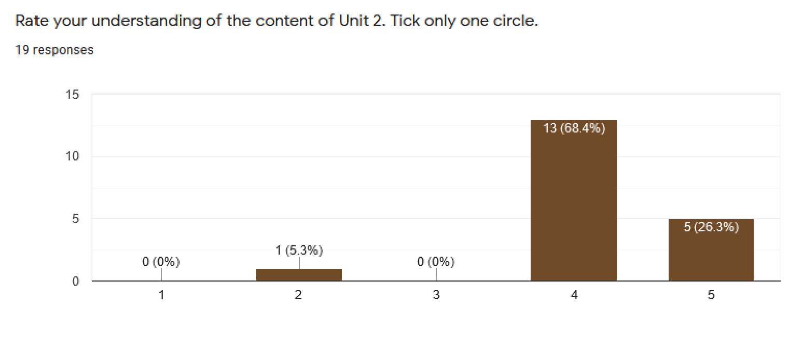

**2. Consistency and Relevance**

Participants have been asked to rate the consistency and relevance of the lesson learning material in relation to the Unit 2 Learning Outcomes. They used a scale from 1 (not consistent and relevant at all) to 5 (completely consistent and relevant).

31.6% of the learners reported that they found the material completely consistent and relevant; another 47.4% found the material rather consistent and relevant; 10.5 % (2 learners) found the material in the middle of the extreme opinions, while 2 persons (10.5%) thought that the material was rather inconsistent.

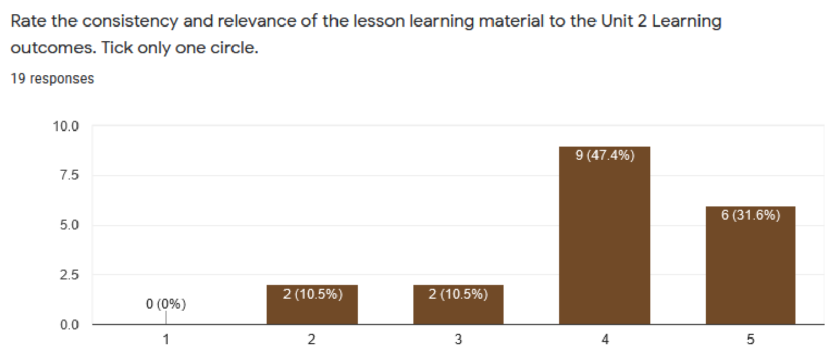

1. **Quality of the Content and the Examples Presented**

Learners’ opinions about the quality of content of Unit 2 was mostly positive but the answers were spread between excellent quality – 36.8% (7 respondents), good quality – 26.3% (5 respondents), neither excellent, not poor - 31.6% (6 learners). One learner felt that the quality is rather poor (5.3%).

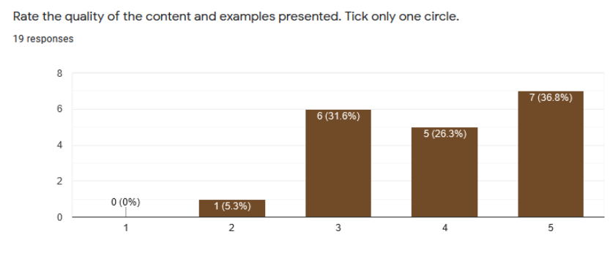

**4. Likes and Dislikes**

When asked about the specific examples of what they liked or disliked about 1. the content presented and 2. the examples given in Unit 2, most participants expressed satisfaction and shared positive experiences. Some concerns were also shared.

**Likes:**

Participants liked the interesting, informative content, the variety of videos and text. The video clips chosen were found to be very explanatory.

*“All study cases were clear examples which I liked the most.”*

*“I liked the short videos that were presented at the beginning of each topic; they were straight to the point and useful”.*

*“Great variety of content provided between videos and text. I like the use of real life applications of Restorative Practice. Very informative.”*

*“I liked that there is a variation in content. The Podcasts and Ted talks are excellent. “*

**Dislikes:**

Some concerns were related to the relevance of case studies, the time needed for Unit 2 and the need for some instructions in order to follow the material. People liked the content and found it excellent, in particular the video presentations and articles. The content is easy to follow and understand, the examples are relevant and illustrative to the particular theory used.

*“Case studies are not very informative, more scientific papers are needed”.*

*“The order of the assessments was incorrect and in the wrong order. I spent quite a bit of time researching the answers as they were not covered until later in the course. Also it is assumed that people know how to create an implementation proposal again this is not something I have ever come across in my job and found it difficult to complete this part of the course without support or guidance. It would be very useful to have a booklet of course notes to reduce the time spent writing notes and having to return to different sections to check to answer assessments.”*

*“I find the example case studies difficult to use as I feel they are a bit vague and I find myself looking for more information before deciding what intervention might be the most appropriate.”*

*“Some of the case-studies and examples were very long and time consuming.”*

A few learners mentioned that content repeated itself too often; some content was a repetition of Unit 1.

*“I sometimes find the content repetitive however it serves to help certain concepts stick - I like the way content is dealt with incrementally and all the examples provided to complement theory.”*

**5. Most Useful and Interesting Parts of Unit 2**

The content was found to be useful by most learners. They liked the case studies and examples, videos, the topics of ADR and restorative practice in the workplace. The video clips and resources based on RP in schools and communities and the understanding more about the proactive/reactive models given were also appreciated.

*“The videos of RP in action are even more helpful in my gaining understanding of how it works.”*

*“For me RP in prisons, Interculturalism as a concept, and the peacemaking circles.”*

*“The work of Kay Pranis described in the Driftwood exercise and that of Jamie Williams on the Peace Making Circle were very stimulating.”*

*“Wagga Wagga Model”.*

*“ I really enjoyed the Ted talks about the way in which Art and RP can be combined to offer a voice to the more vulnerable groups in society.”*

**6. Least Useful and Interesting Parts of Unit 2**

The question “What part of Unit 1 did you find least useful and interesting?” received 19 responses. Some learners made a difference between “useful” and “interesting” information. While they found information generally useful, some bits were described as not that interesting.

“I found the information around ADR the least interesting but all the information useful.”

Others complained about “*similar questions requiring long answers - would have preferred pre-established questions”.*

Case studies were found not very useful and rather difficult: *“I find the case study of Oldsville or Newtown very difficult to get my head around as I can't get a feeling for the place.”*

Repetition of some parts was a common complaint. *“I just found sections repetitive at times with regards to learning journals and narratives.”*

*“All of it was interesting but the sheer volume was just too much”. “Too much repetition, too much work. The 'time' given for lessons has no relation to the reality of the amount of time that is needed.”*

*“Without formal lectures, long articles are difficult to take apart to find the main points.”*

Other learners were happy with the content and its volume. *“I didn't find anything that wasn't worth learning.”*

**7. Clarity and Logic**

Regarding clarity and logic of the content, there was some work to be done by the course developers. The question *“Was the content of Unit 2 arranged in a clear and logical way? Tick only one circle?”* was answered as follows: only quarter of the respondents, (5 out of 19) or 26.3%, found the content completely clear and logical; another 26.3 % (5 people) found the content rather clear and logical; and 42.1% (8 people out of 19) found it in between clear and unclear. 2 people (5.3%) found the content rather unclear. There was room for improvement of the content organisation and clarity of its presentation, especially because similar results were found with the evaluation of Unit 1. Both Units were evaluated in a similar manner.

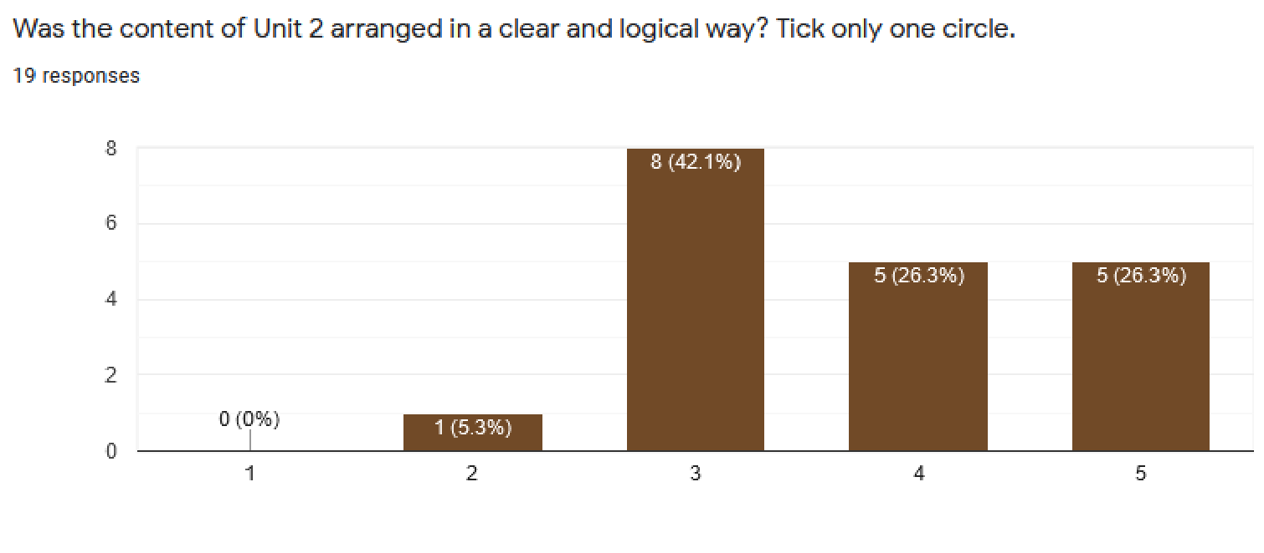

**8. Relevance of Assignments**

Most participants, 47.4% (or 9 people) found the assignments to be in the middle of completely relevant and completely irrelevant. The rest found assignments as follows: 10.5% (2 people) found the assignment to be completely relevant while 42.1% (8 people) felt it was rather relevant. 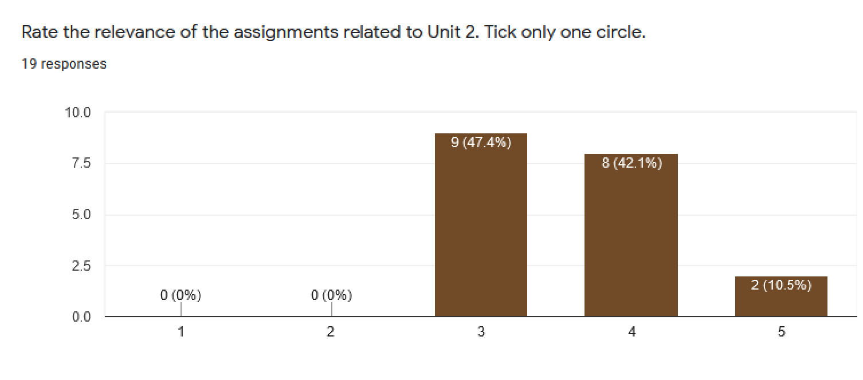

**9. Timing**

Course participants were asked *“Was the amount of time it took to complete Unit 2 appropriate? Why or why not?”.*

Only a couple of people stated that the time was appropriate: *“Amount of time was appropriate”, “Yes, it was because I had enough time.”*

Similar to Unit 1, most answers have shown that learners found that Unit 2 took too long.

*“No, time was not appropriate. I it took way to long and none of it made sense”. It was very hard to do it without any learning from others.” “For me no, I was overwhelmed with reading content”.*

*“In general all classes took me longer than expected time, and the questions inside the units were for me too much time consumers, but maybe because I am overwhelmed and seems that 24 hrs a day is too short for me.”*

*“No, the time suggestions for the activities does not take into account the amount of time it takes to compose and answer and time spent going back through the platform to find evidence to support your answer. The platform is not easily accessible and it takes quite a bit of time to find the information that you require. Some of the questions in the learning journals are repetitive and not relevant and the sheer volume of learning journals in this Unit 2 I feel was unnecessary.”*

*“There is no time to look up what we would like to learn more about, as per your question at the end of each topic, because the content is very time consuming. I do not think your time - frame matches how long we spend doing the activities. We spend longer based on all of the feedback from my fellow - students. For example, we do not have time to read Marshall Rosenberg's book Non-Violent Communication.”*

*“Inappropriate! As I found it very time consuming. This was frustrating as I found many of the assessments repetitive. The assessment questions could be a lot more focussed and specific as to what they are looking for. I find them vague. I'm not sure if I'm giving the answer that is expected from me if I am writing similar answers to more than one question.”*

*“No. I have been having problems with the Moodle platform!”*

*“No, not in the slightest. It took me personally so long to do some parts of the unit and having to move backwards and forwards in each section is really time consuming.”*

*“No, it always takes much more than expected, expecting a lesson to take 90 mins, when there are several videos, some of which are of an hour or so... it takes almost 3-4 hrs to really fully finish each lesson.”*

*“I spent about four times the allocated length of time doing assessments.”*

*“Absolutely not. Too time consuming.”*

*“It took me a lot longer to complete the Unit than expected. As a result, I am starting Unit 3 later than the schedule.”*

*“More time is necessary - this course is loaded with content and more time is needed to integrate what is being learnt. “*

*“No, at times I felt under pressure to keep up with the timeframes especially when doing the short and long narratives.”*

*“No, it was not. There is a lot of work to cover, to read, to understand, and to research. The amount of time is way off, in my opinion.“*

*“There was a lot of content to cover in a week, I had to spend most weekends trying to catch up. The timing is not suited to someone working full time. I would consider this a full-time course as opposed to part time.”*

*“It took me too long.”*

**Platform Design**

**10. Understanding the Moodle Platform**

Similar to Unit 1, for many participants the Moodle platform was a challenge when working on Unit 2. Still, more people got skillful to navigate it because 36.8% (7 out of 19 people) found it easy to understand and 31.6% (6 people) - rather easy to understand. 21.1% (4 people) placed their answer between easy and not easy to understand the platform, while 10.5% (2 people) had real difficulties navigating it.

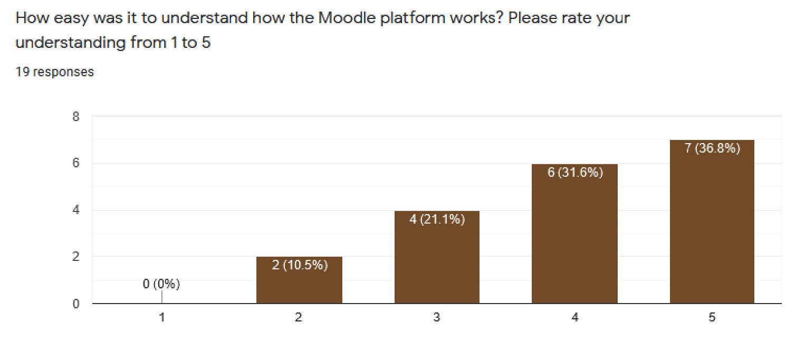

**11. Ease of Navigation Through Different Features**

The above difficulty was confirmed when the learners were asked to rate the ease of navigation of different features of Moodle platform. Again, similar to Unit 1, the learners had difficulties to navigate through different features of Unit 2.

Still, almost 1/3 of those who answered the evaluation questionnaire declared no difficulty (31.6% - 6 people). The rest tend to show discomfort in navigation of Moodle features; especially 3 people (15.8%) declared distinct difficulties.

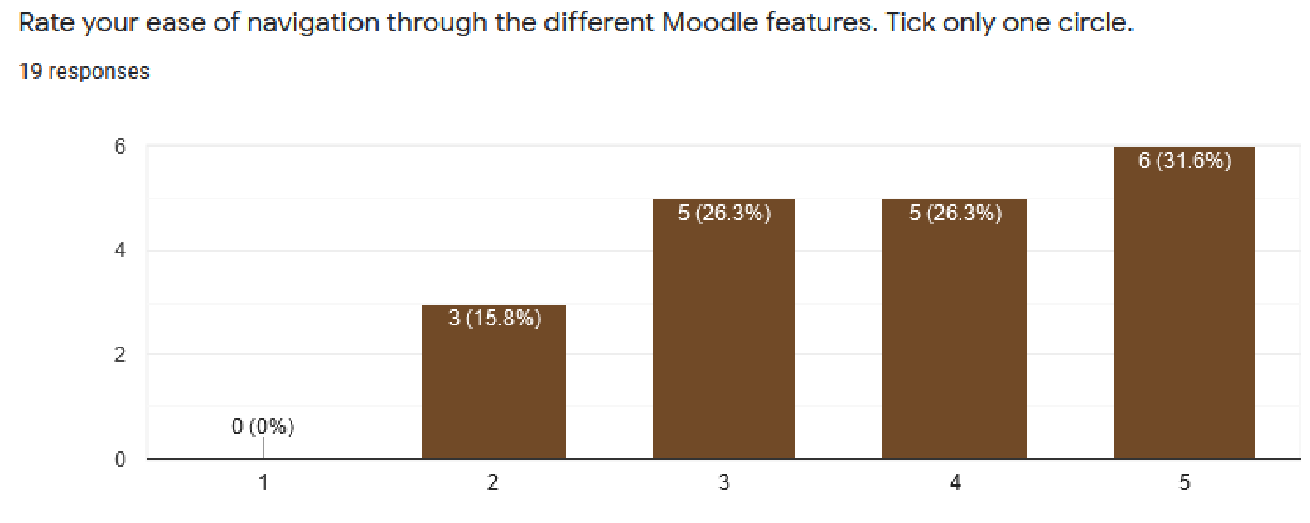

**12. Visual Design**

When asked to rate the overall visual design, including the images and graphics used in Unit 2, 42.1% of learners rated it as completely satisfactory; 47.4% - as satisfactory; 5.3% (1 person) rated their answer in the middle between unsatisfactory and completely satisfactory and one person said that the visual design was rather unsatisfactory.

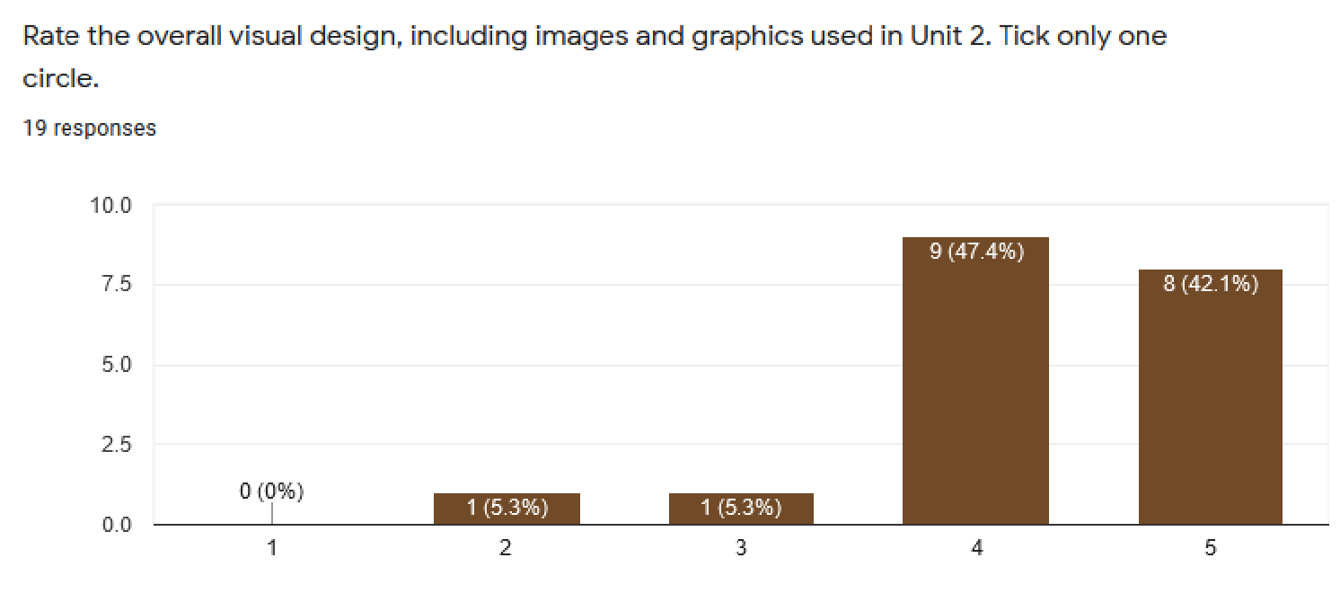

**13. Legibility**

The legibility of text and fonts in Unit 2 were rated positive by most learners: 63.2% rated it as completely legible; 31.6% rated it as rather legible and only one person (5.3%) said it was between legible and illegible. No one rated the text and the font as illegible.

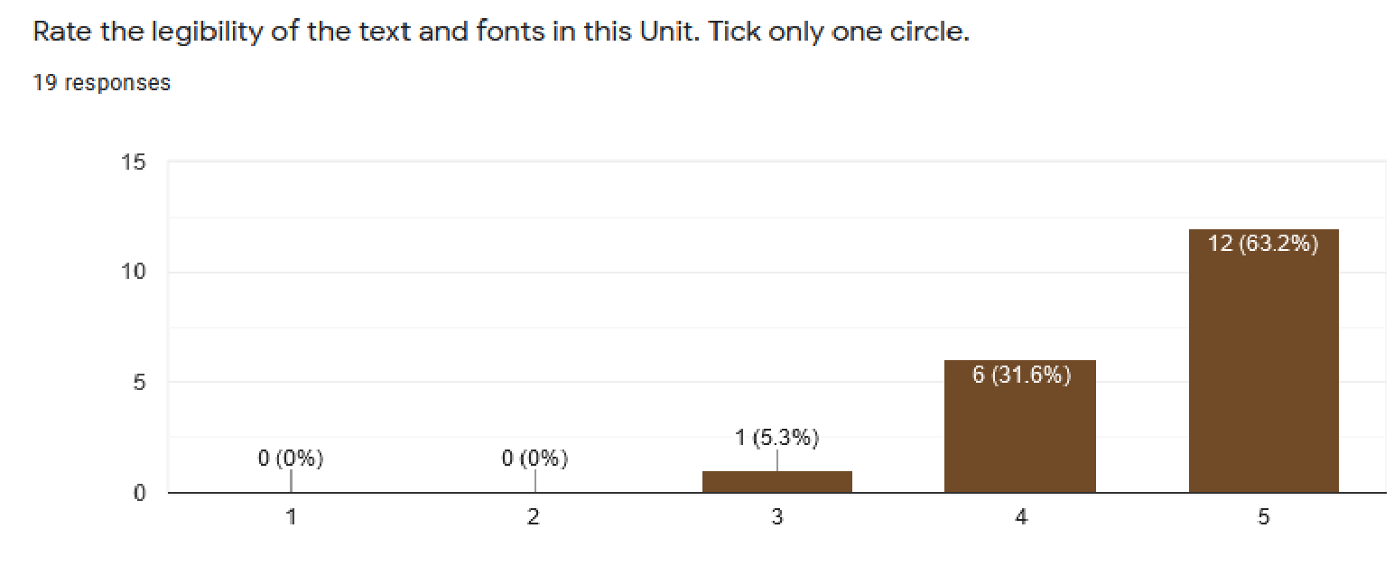

**14. Quality of Audio-Visual Materials**

Most of the participants in the course evaluated the quality of audio-visual materials as being of excellent quality (57.9%) and good quality (31.6%). Only 2 learners (10.5%) circled the middle answer - that the quality was neither good, nor bad.

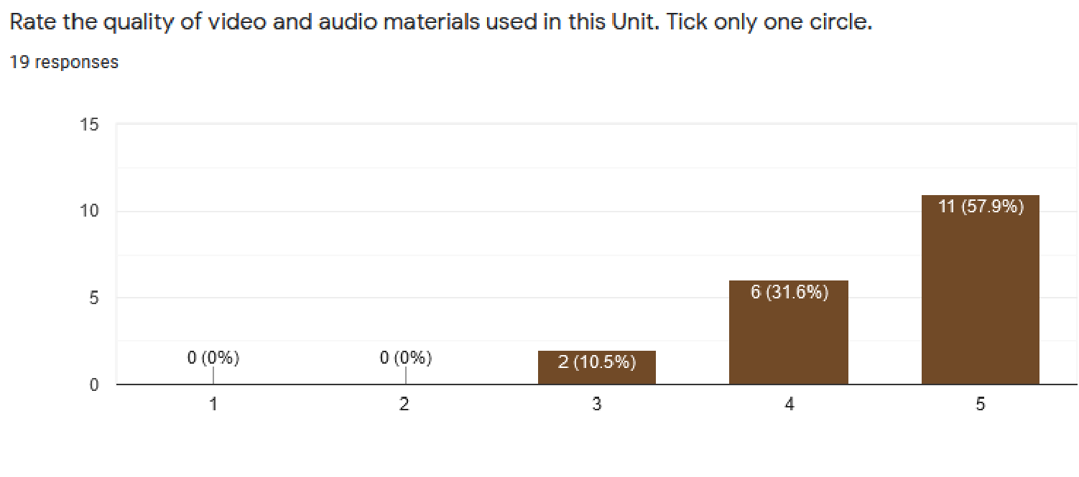

**15. Examples about the Good and Bad Qualities of the Moodle Platform**

Learners were asked *“Please provide any specific examples about what you liked or did not like about a) the Moodle platform and b) the images, video and audio materials presented.”*

Generally, people liked the layout and the video.

*“The videos, podcasts and images are excellent.”*

*“I particularly likes the "Mindsight" talk by Dan Siegel. I thought it was very interesting”*

*“The material and the way they are presented are good and relevant, and the graphics are cute.”*

*“I liked the interactiveness.”*

Here are some issues and recommendations on how to improve the platform as shared by the 19 learners in regard to Unit 2:

* To insert structure /table of content.

*“Maybe audio/video material could be revised to contain a structure/ table of contents, as to better navigate through the material.”*

* To insert a word count functionality

*“No word count is available and a particular video was not clear, but overall very satisfied”*

* Better navigation through the platform

*“To answer assignments we must return to certain parts of the topic. It can be hard to navigate this and takes quite a bit of time to get back to a specific section.”*

* Saving function to be inserted

*“Not able to save”; “Moodle needs improvement because it should not lose your work.”*

*“The moodle platform seems to randomly not save material.”*

*“Sometimes the moodle does not save my work, so when I come back to continue a lesson I would need to copy and paste all my answers back into the boxes - this is really time consuming and frustrating.”*

* Fix the platform so it does not stop working/ freezing and make it easy to access it

*“Moodle platform is not always co-operating.”*

*“..it’s very frustrating when the platform suddenly stops working if you've stopped to read something, and in the meantime it decides to stop working, so you have to stay reloading the lesson again - it’s a waste of time.”*

*“I just found it hard to navigate around Moodle. I had to shut down all other applications that I use through work in order to access Moodle.”*

*“It takes ages to get into the Moodle platform.”*

* No option to print pdf

*“I like how the information is presented but it is disappointing that there is no pdf to print off at the end. Therefore, I find it time consuming to take notes.”*

**16. Tutorials**

The question *“Were the Unit 1 Tutorials useful to you? Why or Why not?”* was answered in a very positive way.

*“Very usefull. I can clearer see step by step what is RP in essence, the differences, even though it seems so simmilar but than you can notice the differences after watching the videos. What I did not like is the reading and writing - too long and too many.”*

*“The differentiation and overlap between mediation and RJ/RP is important.”*

*“I would like further information about how to organise the practice groups that are to take place on Zoom.”*

*“It was good to see the history and how and why restorative evolved.”*

Too much time was spent on complaints about the course during the tutorial:

*“It was useful to hear how my fellow - students are getting on. They are finding the course very time – consuming”*

*“It was okay but so much time is given over to complaints about the course. This is frustrating. I think Claire and Andy are very engaging but the tutorials are being hijacked by complaints of lack of clarity around the course.”*

*“I wish we get more clear answers to our concerns.”*

*“Yes and no, it was basically a collection of complaints. whilst I appreciate being able to voice my concerns, it still wasn't really restorative.”*

*“Very useful as it gave an opportunity to share opinions and ideas to improve the course”.*

*“It was mainly frustrating.”*

*“A lot of time was spent on complaints which did not leave enough time for the other aspects to be covered.”*

*“We put forward our concerns and we got an email in reply to them.”*

**17. What did you like most about tutorials?**

Numerous positive things were shared in relation to the tutorial:

* The study cases and videos, examples, clarity
* Meeting and connecting with other students and tutors
* The participants' involvement
* The history
* The Opening and the Closing Circles.
* Some of the key areas such as the prisons section and the ADR, together with the peacemaking circles and the case studies

*“I like the that it covered theory and practical examples. “*

*“Claire and Andy are very patient, friendly and engaging.”*

*“It's helpful to have live sessions with Claire and Andy so that any questions can be addressed in real time. Its also great to catch up with the rest of the class - creates a sense of 'going through the experience together'.”*

*“There was not enough time to really connect with the other learners, but it was good to see that we all seemed to be in the same boat regarding the overload of work.”*

*“Given an opportunity to discuss any issues we had.”*

**18. What did you like least about tutorials?**

The answers of this question was given in the previous one when some people mentioned that this specific tutorial *“became a forum for complaints.”.*

*“Time was limited”* said others, pointing out that the interesting content had shortage of time to be presented and questions to be answered.

*“I don't think there were enough questions answered at the time.”*

*“The sheer volume of elements and content was overwhelming at times. I would rather less but in more depth. At one point the assessment was done before you covered certain concepts. Also having to trawl backwards and forwards between sections is so time consuming. I also found in the case studies I couldn't submit the answers to questions about who you would invite to the conference, and having spent the time writing them, this was deeply frustrating.”*

*“Felt like our concerns weren't heard.”*

*“Some repetition from Unit 1“; “At times its repetitive nature.”*

*“Repetition! And the amount of time is not enough.”*

*“We spent 2 hours covering issues, we did not cover anything to do with RP. I would like tutorials to strengthen what we have learned in the content.”*

**19. Topics Not Covered in Unit 2**

The question: *“What topics would you like to see addressed in Unit 2 that were not covered?”* received 19 responses. Most of them said that they had in fact nothing more to add to Unit 2.

“*Ï guess it was obvios and clear materia in each class and topic.”*

*“You couldn't fit any more in to the unit. It is absolutely saturated with materials. “*

*“I don't know. I felt it was very comprehensive... maybe a little more guidance on researching RP in our own country... This took me about 7 hours, very interesting but very time consuming.”*

* Others had some suggestions for additional content:

*“Reflecting on/dealing with power imbalances and structural discrimination and attitudes on punishment/ crime/ deviant behaviour.”*

* There was a suggestion to have time in the tutorial to discuss real case studies instead of listening to presentations.

*“Could we have some questions other than what is going well and what is not going well? I think that there is some good knowledge in the group and a wider discussion about real case studies would be far more interesting than listening to people giving out.”*

*“We need more practical case studies.”*

*“We need appropriate feedback discussions and more clear instructions.”*

**20. Overall Satisfaction**

The overall feedback about Unit 2 was positive: rather satisfied was selected by 42.1% of the participants and very satisfied - 15.8%. 31.6% were neither satisfied, nor dissatisfied; only two students rated dissatisfied.

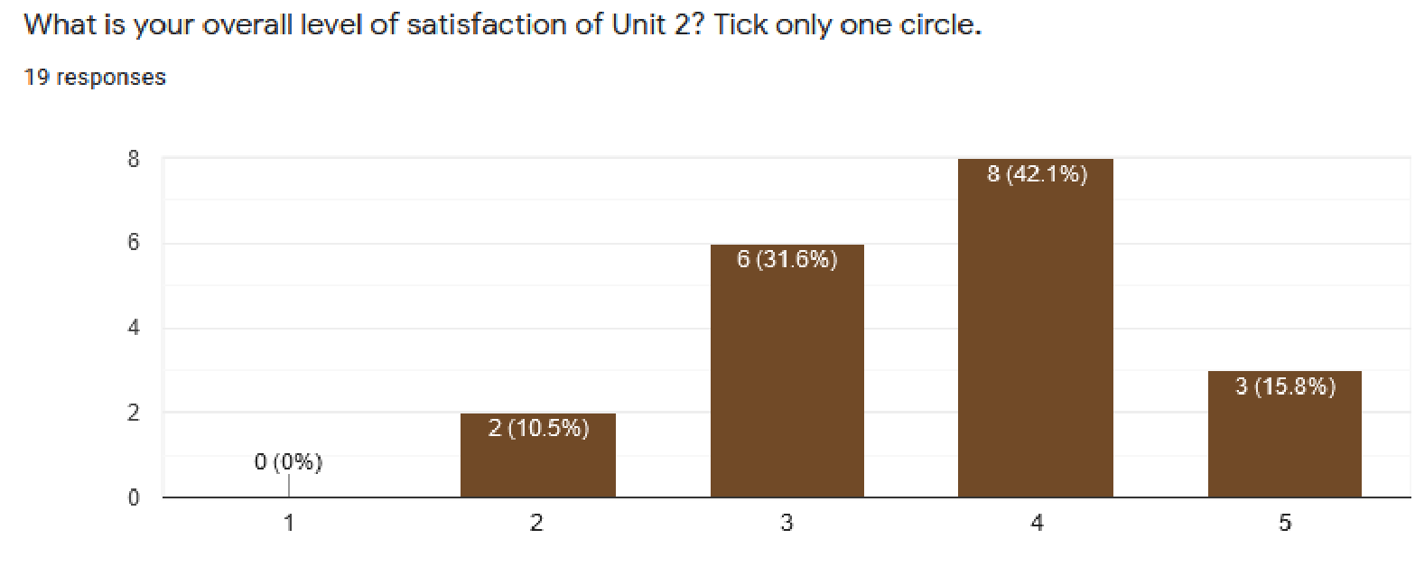

**Conclusion – Unit 2**

Many people were appreciative of the work done for this course and expressed great interest in the topic of restorative practice and its applications.

There were still concerns and persistent issues that were not resolved in or after Unit 1. Learners knowing that their feedback is important for improvement of the course have been quite detailed with their feedback and recommendations. They were asked once again at the end of the evaluation questionnaire to share final thoughts and again the key issues mentioned above were underlined once more.

It seems that many learners had difficulties with this section. It may be the reason why in the beginning of May 2021 only 19 people have completed it which is only two thirds of those who completed Unit 1 in January and February 2021.

*“I found this section very hard to understand none of the material seemed to add up and all the questions seemed to be the same I found learning without any instruction or lectures to be very challenging”.*

There were frustrations related to instructions, the time frame, assessments and the Moodle navigation.

*“Please if possible send RP questions by its own topic and the script model we could use in each case. Thank you ! And if possible, pre-established questions and answers and more videos than reading!”*

*“I find that only one of the questions in the learning journal is relevant. I'm not sure what purpose the other three serve?”*

*“Please review the time frames for the topics and assessments!”.*

The Moodle platform was problematic for quite a few learners, especially in terms of saving the work done and obviously created frustrations.

*“There should be a save button to ensure that we do not lose work or better still it should save automatically every few minutes. Also there was a glitch that I informed Louis Acquilina about and I lost work in the final topic that I had to input twice.”*

*“Thank you. I was overwhelmed at times and found many of the concepts covered very interesting, but I was continually anxious to get to the next stage, which doesn't feel the way it should. I found some of the assessments and written tasks to be very repetitious.”*

The course was perceived as very time consuming. And as one learner said: *“this is a course that in order to get it done, when considering it need to be done after work, it ends up taking up the rest of the day. It's a little inhumane to get it all done. I can't imagine how the rest of the units will be done when I see they are much much longer.”*

**Unit 3**

1. **Understanding the Content**

Participants have been asked to rate their understanding of contents of Unit 3 using a scale from 1 (did not understand at all) to 5 (completely understood). The results show that there was a high level of understanding of the content of Unit 3: all participants understood (13 students or 81,2%) or completely understood (3 students, 18,8%) the content of the course.

No one said that they had difficulties in understanding the content which can be related to improvement of students' learning throughout the course. But since the group was significantly smaller in comparison with those who completed Unit 2 and Unit 3, it could be because of drop out of students who previously reported difficulties during the learning process.

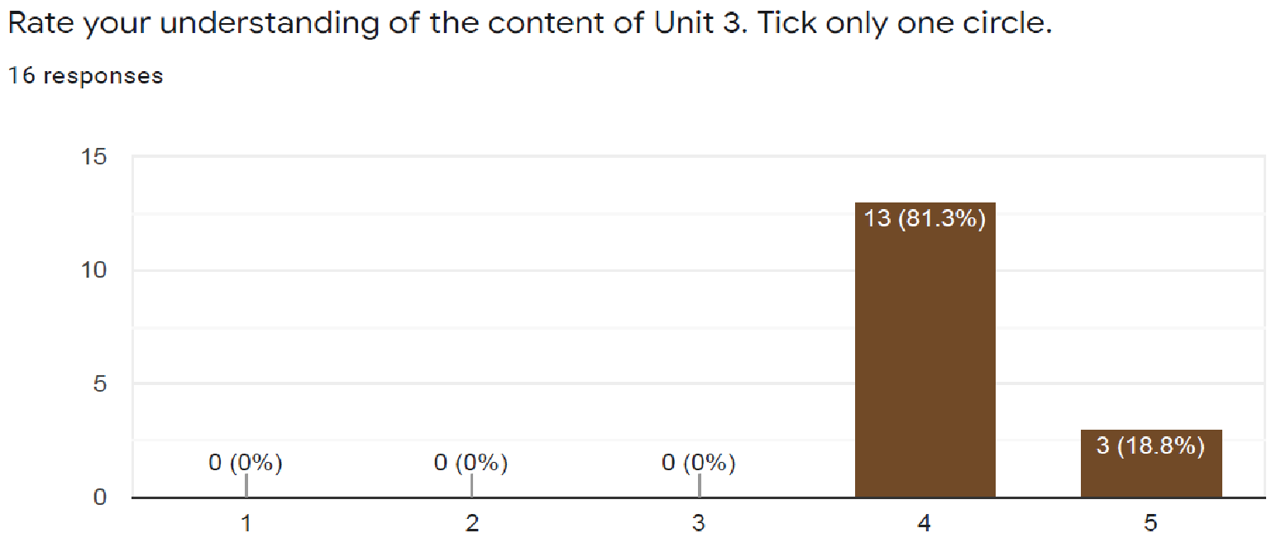

1. **Consistency and Relevance**

Participants have been asked to rate the consistency and relevance of the lesson learning material to the Unit 3 Learning outcomes. They used a scale from 1 (not consistent and relevant at all) to 5 (completely consistent and relevant). 18.8% (3 students) reported that they found the material completely consistent and relevant; most students 68.8% (11) found the material rather consistent and relevant; 12.5% (2 learners) found the material in the middle of the extreme opinions. There were no negative opinions in this respect.

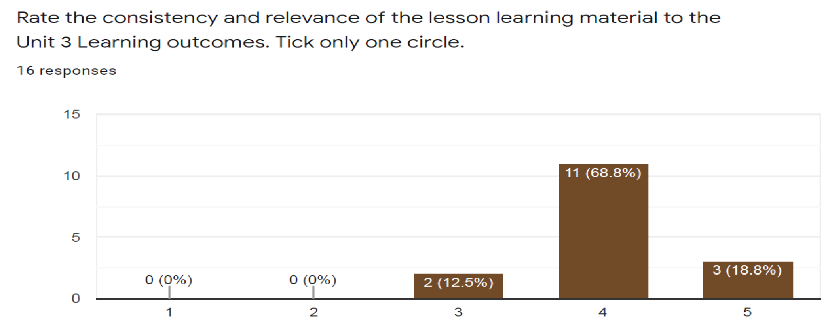

1. **Quality of the Content and the Examples Presented**

Learners’ opinions about the quality of content of Unit 3 was rather positive. Answers were spread between excellent quality – 31.3% (5 respondents), good quality – 37.5% (6 respondents), and neither excellent, not poor - 31.3% (5 learners).

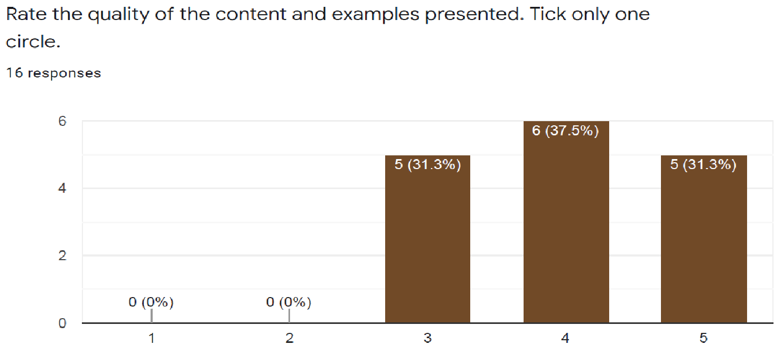

**4. Most Useful and Interesting Parts of Unit 3**

Students were asked *“What part of Unit 3 did you find most useful and interesting?”*. 16 students responded. The following areas were underlined as very useful:

* NVC (nonviolent communication). Students found the work of Marshall Rosenberg very interesting in terms of how it connects to restorative practice.
* The practical areas related to Shame/Guilt, Anger, Emotional Intelligence were found very relevant to RP.
* The 6 Key questions of Restorative Conversations
* Communication, Active Listening and Learning
* The downloads and TED talks and interviews
* Affect Script Psychology. “Greater understanding of my own emotions.”
* Restorative Language
* Starting to learn how to integrate Restorative Language and NVC into our daily interactions.

**5. Least Useful and Interesting Parts of Unit 3**

The question *“What part of Unit 3 did you find least useful and interesting?”* received 16 responses. A few of them had nothing to say and wrote “not applicable”, others said that they found all parts of Unit 3 interesting. Some students described what they found least interesting (or difficult, long):

* Affect Script Psychology was pointed out by a few students as being explained in a too complicated manner. *“I don't think I found it the least useful, I found it wasn't explained in a clear manner thus took me longer to understand the concept in comparison to the remainder of the course material.”*
* Emotional Intelligence
* *“A video presentation by Roger Ebert - Nonviolent communication, Part 2 which was confusing.”*
* *“Too much theory at the beginning of the Unit 3”*

There were references related to the assignments. *“They were very repetitive and at times ambiguous in terms of how they are phrased.”*

Others complained that the lessons were long and difficult to follow. *“The way the lessons as presented I found them difficult to follow at times.”; “The Unit was so long, I would find it difficult to stay at this point.”*

There were students who did not find the checklists and the best practices form useful. *“It felt like a repetition over and over again.”*

**6. Clarity and Logic**

Regarding clarity and logic of the content, again as in previous Units 1 and 2, there was some work to be done by the course developers. The question *“Was the content of Unit 3 arranged in a clear and logical way? Tick only one circle.”* was answered as follows:

Only 2 (12.5%) of respondents found the content completely clear and logical. This is a substantial decrease in clarity perception in comparison with the evaluation of the content clarity of Unit 2 (26.3 % or 5 people) found the content of Unit 2 clear and logical.

More than half the students found the content rather clear and logical – 56.3% (9); and 25% (4) people found the content in between clear and unclear. 6.3% (1 person) found the content rather unclear.

The perception of clarity of content presented was similar in all the three Units which means that the content could benefit from some clarification, perhaps also simplification and shortening.

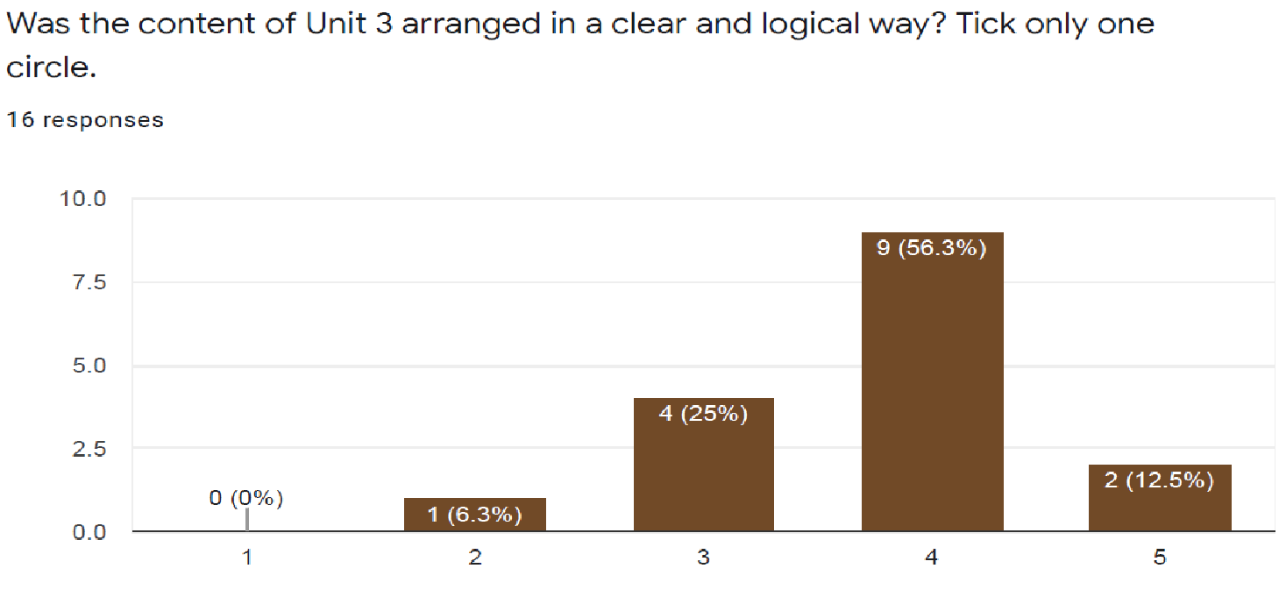

**7. Role Play Practice of Restorative Conversations**

Students were asked *“Was the format and process of role play practice of restorative conversations useful to you? Why or Why not?”* and the answers given to this question were very positive. Students explained that practicing NVC and restorative conversations is crucial for being able to use it in "real life". Practicing helped them in learning restorative language and conversation. They appreciated the opportunity to practice with other colleagues who knew and understood the process as well to put the theoretical knowledge to use.

*“Yes, it’s the next best thing to an actual scenario.”*

Still some concerns were mentioned as well. They were more related to the process of arranging and recording the role play via online contact with another student. Students also needed an opportunity to practice with the larger group and to get feedback from the course tutors prior to recording and submitting their assignment. They would have benefited if the restorative conversations had been demonstrated more thoroughly during the tutorials and more time had been offered to practice with their partner prior to the assessment. As one student said: *“It seemed as thought we were doing if for the assessment, as opposed to learning how to do it for our own future practice.”*

Concerns were especially related to the format of the role play. Recording, uploading, downloading was difficult for students. Some also found the instructions difficult to follow but the tutorial was useful and clarified them.

*“The role play practise was excellent but the tutorial should have been a week of two before it.”*

*“It was very helpful but the process was somewhat confusing at first. Not all students were at the same stage so not everyone understood the process.”*

*“I believe there was space for more role plays, but the amount of work involved does not leave one with much time for more practice.”*

The perception of the format and process of the role play was explored with another two questions to the students.

The question *“What did you like most about the format and process of role play practice of restorative conversations?”* was answered by 16 students and the following were their likes:

* Setting dates with their partner freely and deciding how to work on the tasks themselves.
* Provided an opportunity to practice restorative practice and move away from the theory side of the course and to look at the practical application of restorative practice.
* Being able to pair up and complete the assignment in a safe, non-judgemental supported environment with a partner.
* Topics suggested.
* The feeling of support and camaraderie which developed during the process.
* The simplicity of the role play and conversations.
* Getting to know the other person from the same course.
* Using restorative language with someone who understood the process
* The role play showed the relevance of the course.

The question *“What did you like least about the format and process of role play practice of restorative conversations?”* received the following answers:

* Short time frame. Maybe it would be better if it started in the beginning of the unit practice and continue throughout the whole unit;
* Confusion and hard to understand how it would be graded and what standard was expected considering students didn't have an opportunity to practice with tutors. They found the second peer group session made it very clear but the instructions were difficult to understand at first and caused worry around the role play.
* It was difficult for some students to record themselves.
* It was very hard to create a realistic context as neither of the students were actually directly affected by such a situation in the past.
* Could have been more supported through more workshops and support meetings.

Some students said they did not like that they were very anxious and nervous, role play is not something they like doing. Others said that there was nothing they disliked.

**8. Relevance of Assignments**

Similar to the previous Unit 1 and Unit 2 evaluations, most participants (43.8% or 7 people) found the assignments to be in the middle of completely relevant and completely irrelevant. The rest found assignments as follows: 6.3% or only 1 person found the assignment completely relevant; rather relevant was the answer of 37.5% or 6 people. Two students (12.5% ) found the assignments rather irrelevant.

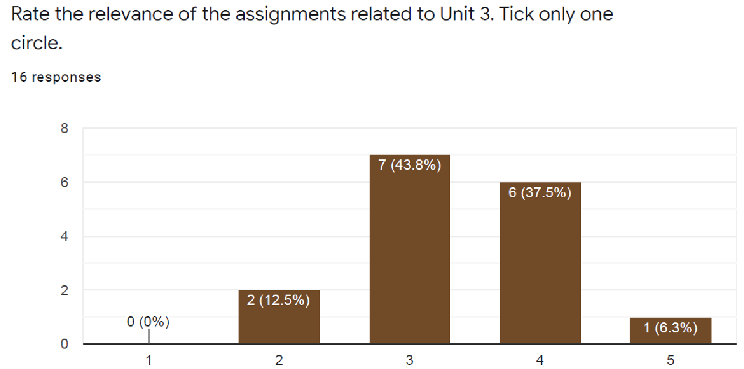

**9**. **Timing**

Course participants were asked *“Was the amount of time it took to complete the Unit 3 appropriate? Why or why not?”*

Similar to Units 1 and 2 – students said that it took too long a time to complete Unit 3.

A couple of students were comfortable with the time schedule because there were no learning journals and the assessments had multiple choices and right or wrong questions.

But the majority of the students said that it took a lot of time to complete the unit. An extension was required for the whole group in order to complete the assignments. The number of assignments was unnecessary and they were very repetitive at times. There was a lot of material to be covered in the allocated time and some students were behind as per the course schedule despite spending a significant number of hours working on the course material, completing assessments and attending the class and smaller group tutorials.

*“Huge amounts of time went into this unit. If the course is to be graded in a constant assessment format I don't understand the logic of having long narrative questions at the end of topics. If it is to be graded through essay style assessment, I don't understand the constant assessment. There is an enormous amount of repetition in the assessments which is really ruining my enjoyment of the course.”*

*“I spent 5 times longer doing assessments than was allocated for them. There was too much detailed examination of the same content with only slightly different nuances in the questions.”*

*“It took longer than was recommended. The assessment took a lot of time to complete.”*

*“Definitely not. Time frames are surreal.”*

*“No, once again the underestimation of the course was way off. And the sheer amount of repetition work there was in the unit was absurd. It really feels like there is just stuff added in to 'fill up' the time, and this ends up making something interesting into tedious, arduous and boring, besides literally sucking the joy out of doing this course. There is just too much hours that are not accounted for and there is just too much required for such a low level course. This is a full time, and definitely not a part time "do at your pace" course.”*

*“This unit was too overloaded with content - sometimes repetitive content that felt unnecessary and frustrating considering the time constraints.”*

*“There is not enough time to read, research and write the assignments. There is too much content for the amount of time. It would be more beneficial to be given more time.”*

**Platform Design**

**10. Understanding the Moodle Platform**

Similar to Units 1 and 2, for many participants the Moodle platform was a challenge when working on Unit 3. The results show that 43.8% (7 out of 16 people) found it easy to understand the Moodle platform; 18,8% (3 people) - rather easy to understand it; 25% (4 people) placed their answer between easy and not easy to understand the platform, while 12.5% (2 people) had real difficulties to navigate it.

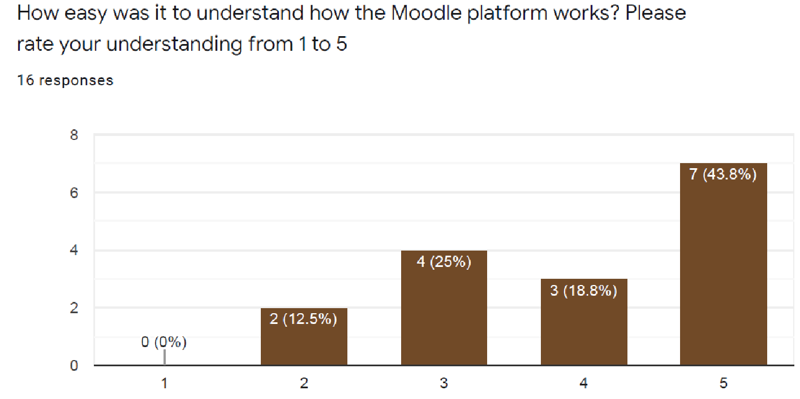

**11. Ease of Navigation Through Different Features**

Learners were asked to rate the ease of navigation of different features of Moodle platform. Again, similar to Unit 1 and Unit 2, the learners had more or less difficulties navigating through different features of Unit 3. The results show that 43.8% (7) of students declared that it was easy for them to navigate the platform. 18.8% (3) answered with rather easy; 25% (4) pointed the middle answer; and 12.5% (2) showed clear discomfort in navigation of Moodle features by answering rather difficult.

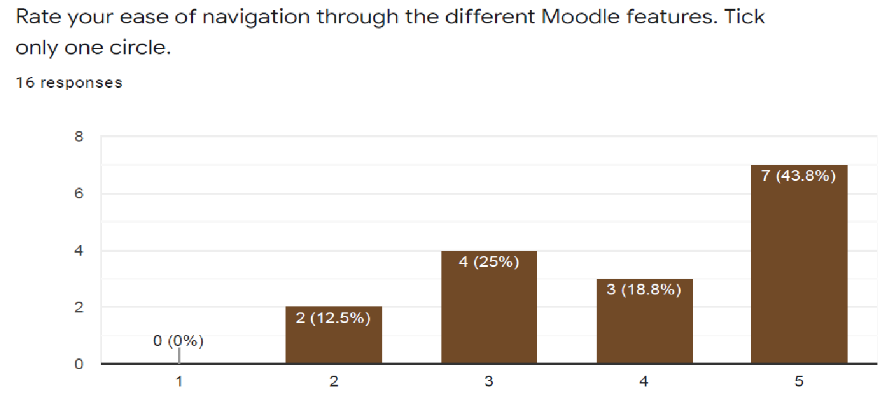

**12. Visual Design**

When asked to rate the overall visual design, including the images and graphics used in Unit 3, 43.8% (7) of the learners rated it as completely satisfactory; 37.5% - as satisfactory; 18.8% (3) persons had rated their answer in the middle between unsatisfactory and completely satisfactory. These were rather positive results because no one has shown distinct dissatisfaction with the visual design.

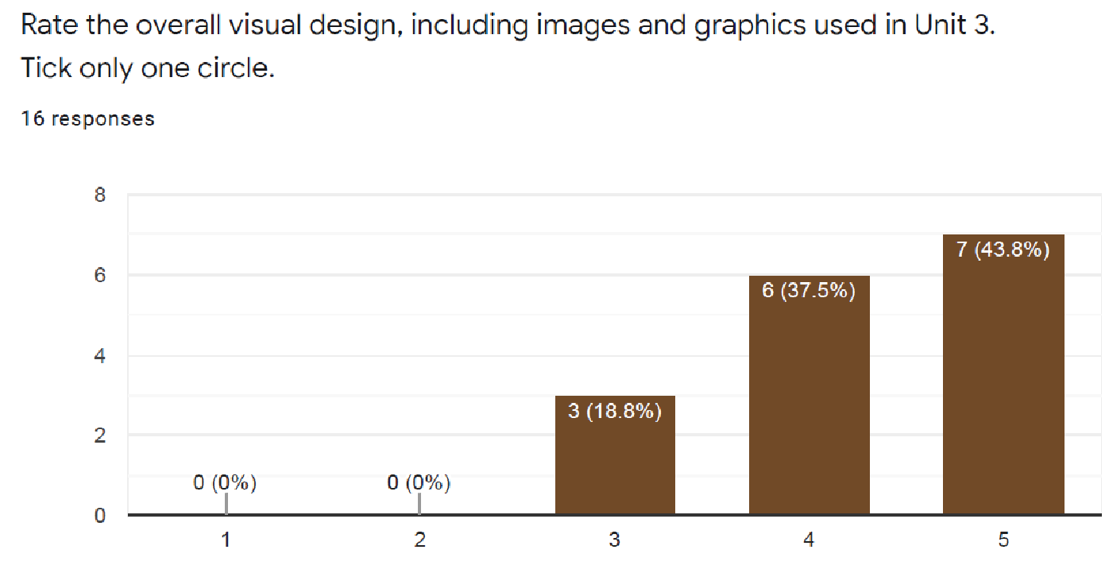

**13. Legibility**

The legibility of text and fonts in Unit 3 were rated positive by most learners: 56.3% (9) rated it as completely legible; 43.8% rated it as rather legible.

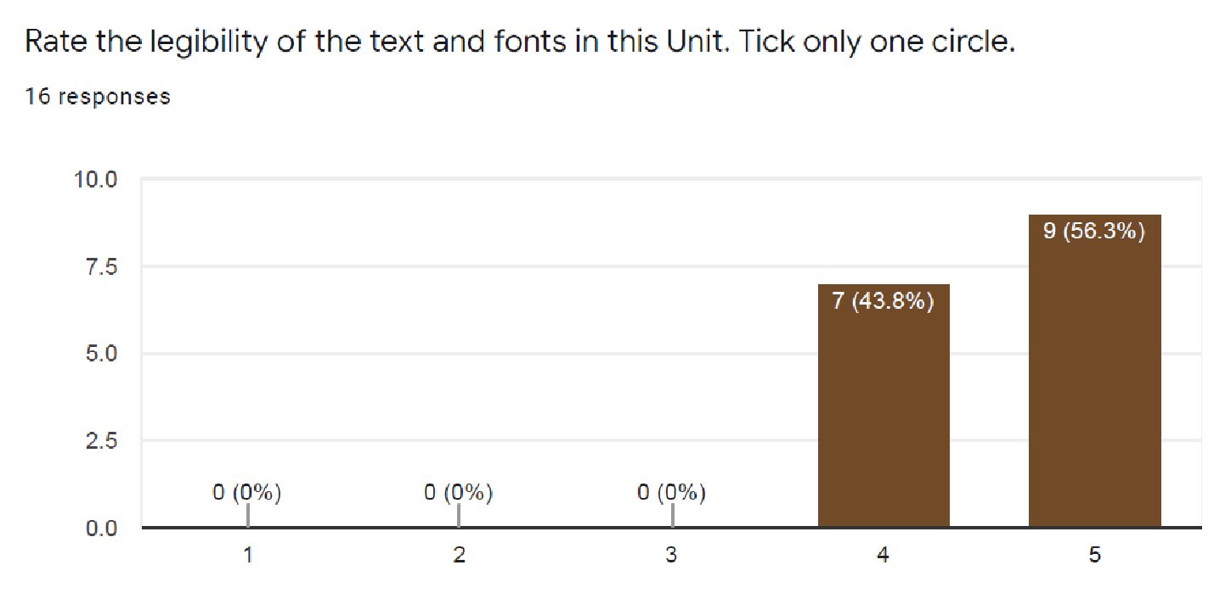

**14. Quality of Audio-Visual Materials**

Most participants in the course evaluated the quality of video and audio materials as being of excellent quality (43.8%, 7 students) and good quality (25.6%, 4 students). 4 learners (25%) circled the middle answer - that the quality is neither good, nor bad and one student (6.3%) stated that the audio-visual material was of poor quality.

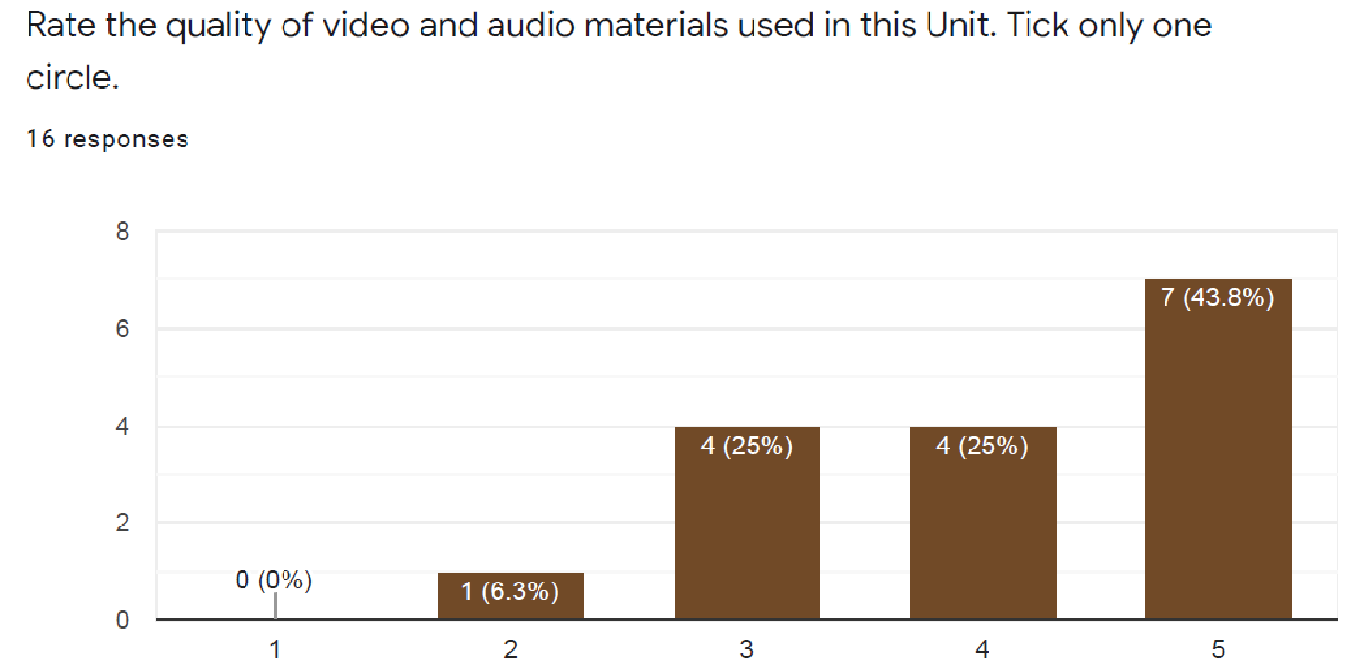

**15. Examples about the Good and Bad Qualities of the Moodle Platform**

Learners were asked *“Please provide any specific examples about what you liked or did not like about a) the Moodle platform and b) the images, video and audio materials presented.”*

**Positive** qualities were listed as follows:

* A clear structure
* The content of the course and how it is provided is excellent
* The YouTube clips in this unit were interesting
* Graphics was good
* The Moodle is quite straightforward and easy to access
* The interactive aspect

**Dislikes:**

* Not enough scientific literature
* Questions related to video films were not properly positioned and the answer box is not immediately available

*“I don't like how when we are asked to watch a video, there are sometimes questions underneath which only appear as we scroll down. I feel like they should be highlighted prior to watching the video so we can consider them when watching the video for the first time. Also sometimes, the answer box isn't immediately available and I must close the page and reopen the page to complete the questions.”*

* Moodle was down regularly (specifically after 10.00 pm in Malta)
* Still issues with work not being saved on Moodle and having to be redone
* It does not navigate backwards properly when required

*“Each time I look at a video clip and then want to go back to where I was on the presentation I am redirected to the Unit instead of the exact point where I left off.”*

* Audio quality in a lot of cases was not so good /booming, hard to pick up some of the pronunciations

*“The Audio is not always easy to listen to especially when there are different ethnic groups involved.”*

* Logging in takes time

*“Logging in takes more time than Moodle platforms I have used before. It kicks you out and you have to go back to the beginning if you have clicked on one of the attachments. It give you a message about Scorm pop up window or something. It wastes time.”*

* A lot of repetition

*“A lot of repetition, sometimes it doesn't work, sometimes it refreshes without me knowing, so this forces me to always work on a word document otherwise I lose all my work. So the Moodle journal is de-facto useless to use unless I want to waste time re-doing most of the work over again, besides me having to stay copy-pasting the questions onto the word document - so it's once again a waste of time.”*

**16. Tutorials**

The question *“Was the Unit 3 Zoom Tutorial with the Tutors from CDI useful to you? Why or Why not?”* was answered in a very positive way.

A lot of positive feedback was provided in relation to the Unit 3 tutorials conducted by the CDI. People shared that the tutors were extremely helpful and that they felt at ease with them. Tutors explained the practical work and people appreciated clarifications on issues and heard what others’ experiences were. Students appreciated the information shared and the space for dialogue.

*“It is always very useful to observe how restorative circles happen within the context of live tutorial & to have the space to ask questions. It is also great to hear how other students are navigating through the course.”*

*“Claire and Andy are always ready to listen, support and follow up on requests.”*

*“Yes. They were able to show us an actual example of what we expected to do in our peer practice assessment”.*

Some appreciated the tutors doing a second tutorial with them.

*“It was useful; however we did run out of time and have to do an additional one. This was difficult to accommodate another session in an already full timetable but I did find it very helpful.”*

*“The second one was very helpful; it gave clear guidance regarding the practical assessments.”*

Other students felt some frustrations such as:

*“Not one bit (useful) as they never have anwers to the questions we ask”.*

*“There were so many issues to discuss so a lot of questions remained unanswered.”*

*“Not really, because most participants had a lot of say, myself included, about the amount of work and the lack of time. Not enough time to discuss anything about the contents of the unit.”*

*“Tutorials were not useful: tutors seem to be uninformed about the tasks in the course. Tutors had technical problems, which leads to difficulties and misunderstandings. Tutors seem to have no insight in the structure and processes at MCAST.”*

**17. What did you like most about the Unit 3 Zoom Tutorial with the Tutors from CDI?**

Students were happy with tutorials and tutors, who listened to what students had to say. They got some clarity and answers. Tutorials made them feel included in a community of learners so they have listened to others and seen that they are not the only one with issues, all are in the same boat. The Questions/Answers session was very much appreciated. Students enjoy connecting with like minded people from a variety of countries and backgrounds.

The opportunity to observe a restorative language and restorative conversation and see what was expected for their assessment was appreciated. *“It is always very useful to observe how restorative circles happen within the context of live tutorial & to have the space to ask questions. It is also great to hear how other students are navigating through the course.”*

**18. What did you like least about the Unit 3 Zoom Tutorial with the Tutors from CDI?**

Many students did not have any dislikes to share.

A few concerns were shared by a small number of participants who wanted more tutorial (at least two tutorials per module should be planned and announced far in advance); the timing of the tutorials was an issue for some of them – they insisted that these tutorials had to be much sooner in the course structure.

*“I did not like how close to the due date for our RL & RC assignment this was held. If it was held 2 weeks earlier, we could have had more time to practice with our partner.”*

A few students said that there was not enough time to discuss the content of Unit 3 because there was a substantial amount of time taken up with complaints. The time was too short, and the internet connection was not great at the last tutorial.

**19. Overall Satisfaction**

The overall feedback about Unit 3 was rather positive: rather satisfied declared 50.0 % (8) of participants and very satisfied only one 6.3%.

43.8% (7) were neither satisfied, nor dissatisfied; there were no students who declared that they were rated dissatisfied or completely dissatisfied.

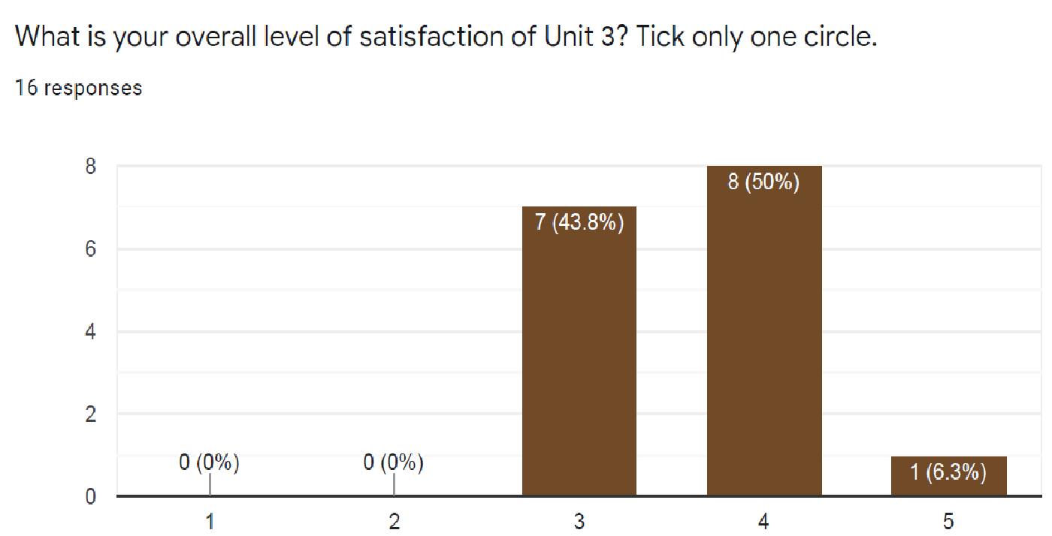

**Conclusion - Unit 3**

The TREP online course proved to be useful for all the 16 learners who completed Unit 3, who besides some difficulties with the process, the materials and the platform navigation, clearly made progress in their learning.

Many students appreciated the learning process, the tutors and the content and paid less attention to the issues related to the development of the online course. Others were more vocal about their concerns and discomfort with the timing, the study pressure and the assessment process but they also liked the topic of restorative practice and its applications.

There were still concerns and persistent issues that were not resolved in or after Unit 1 and Unit 2. Learners wanted a clear time schedule about the feedback of their assignments.

Some students were very specific with their feedback and recommendations, especially those who had difficulties with this section. Most of them were repetitive and similar to the ones mentioned in relation to Unit 1 and Unit 2 which made their frustration greater. Such issues were related to the time pressure, the clarity of the content, the navigation difficulties, and the timing of instructions provided for the role play. The course is perceived as very time consuming, designed to work under time pressure and loaded with too many materials than healthy for productive learning.

These challenges seemed to be crucial for almost half of the students who signed up for the course at the end of 2020 but started to drop out after each Unit. Half of the countries presented in the course also disappeared from the international group at the time this evaluation report was produced.

**Unit 4**

**1. Understanding the Content**

Participants have been asked to rate their understanding of contents of Unit 4 using a scale from 1 (did not understand at all) to 5 (completely understood). The results show that there is a high level of understanding of the content of Unit 4: participants understood (7 students or 38,9%) or completely understood (10 students, 56,6%) the content of the course. Only one student (5,6%) put the level of their understanding of the content in the middle between the extreme points.

No one said that they had difficulties in understanding the content. This can be a result of improvement of students learning throughout the course. Or it can be related to the motivation and competency of students who remained in the course after Unit 4: these are 18 learners in comparison with 28 learners who completed Unit 1.

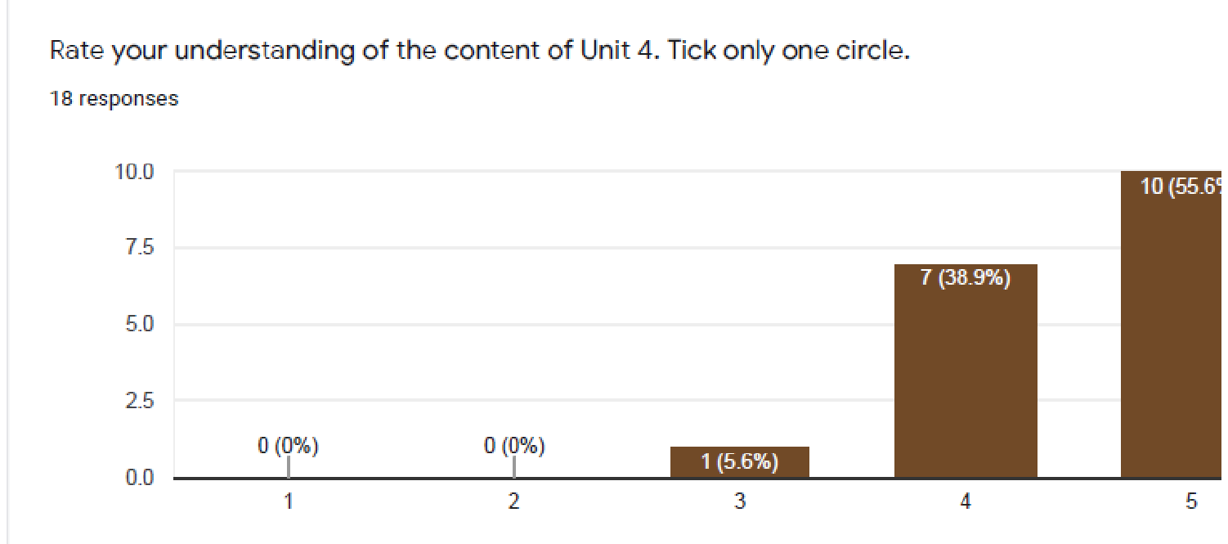

**2. Consistency and Relevance**

Participants have been asked to rate the consistency and relevance of the lesson learning material to the Unit 4 Learning outcomes. They used a scale from 1 (not consistent and relevant at all) to 5 (completely consistent and relevant).

38.9% (7 students) reported that they found the material completely consistent and relevant; half students 50% (9) found the material rather consistent and relevant; 11.1% (2 learners) found the material in the middle of the extreme points. There were no negative opinions in this respect.

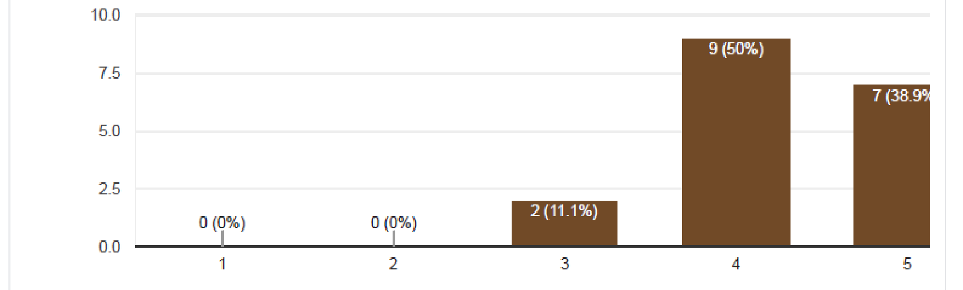

**3. Quality of the Content and the Examples Presented**

Learners’ opinions about the quality of content of Unit 4 is rather positive. Answers are spread between excellent quality – 38.9% (7 respondents), good quality – 38.9% (7 respondents), and neither excellent, not poor - 22.2% (4 learners).

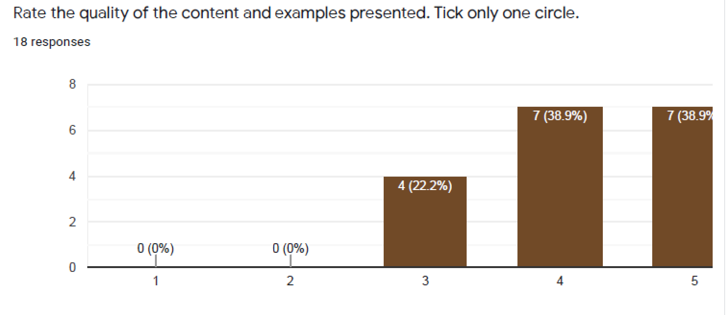

**4. Most Useful and Interesting Parts of Unit 4**

Students were asked *“What part of Unit 4 did you find most useful and interesting?”*. 18 students responded. The following areas were underlined as very useful by many participants:

* Learning about the rationales behind circles, meetings and conferences;
* Restorative conference
* Non-Violent Communication
* Practicalities, checklists, to-do-lists, do's and don'ts lists;
* The preparation and practical sessions - practising scenarios with our peer group;

*“I found the practicals to be the most useful as it enabled us to put our knowledge of the tools into practice and test our skills and where we need improving.”*

*“I found having my Peer Group to be a really positive experience and doing the practicals with them was really useful.”*

*“The videos, podcats, talks - it gave a complete understanding and overview, reactions, timing, the process itself, outcomes, possible turnovers. It is a visual tool what I could use as all material is online.”*

**5. Least Useful and Interesting Parts of Unit 4**

The question *“What part of Unit 4 did you find least useful and interesting?”* received 18 responses. A few of them answered only with “*N/A*” and other few stated “*it was all good*”.

Some students described what they found least interesting.

There was a common complaint about repetition of contentment already covered:

*The repetition of the repetition; The repetition at the start of this unit from prior units.;*

*The repetition within best practice guides;*

*The sheer amount of repetition throughout was just unbearably annoying throughout;*

*The first section, revision of material already covered;*

*Some of it had been covered in previous topics - NVC, social capital;*

*Some of the readings were not relevant to the section we were learning or were too similar to other papers we previously read;*

*There was too much emphasis on the best practice aspect as it was repetitive and asked a number of times; it could be re-structured to be very useful;*

Other students found least interesting fishbowl, the introduction and *“Everything connected to checklists”.*

A couple said that the amount of reading given was too much to handle: *“I think that there is an overload of articles for us to read.”,” Hundreds of pages of reading, time consuming and hard to focus.”*

**6. Clarity and Logic**

The question *“Was the content of Unit 4 arranged in a clear and logical way? Tick only one circle.”* was answered as follows:

Only 4 (22.2%) of respondents found the content of Unit 4 completely clear and logical. This is a persistent problem with all Modules. Seven learners 28.9% found the content rather clear and logical. One third or 33,3% (6) people perceived the content to be between clear and unclear. 5.6% (1 person) found the content completely unclear.

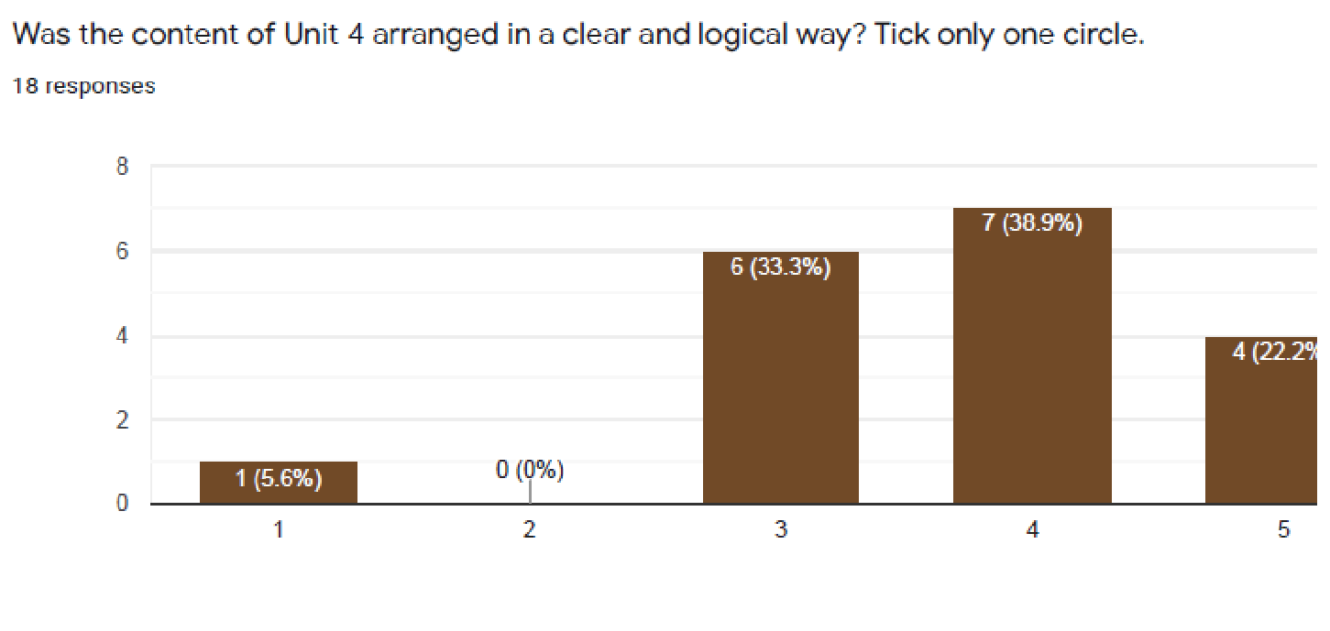

**7. Relevance of Assignments**

Similar to the previous Units 1,2 and 3, many participants who completed Unit 4 - 38,9% or 7 people found the assignments to be in the middle of completely relevant and completely irrelevant. The rest found assignments as follows: 11,1 % or only 2 persons found the assignment completely relevant; rather relevant was the answer of 44.4% or 8 people. One student (5.6%) found the assignments rather irrelevant.

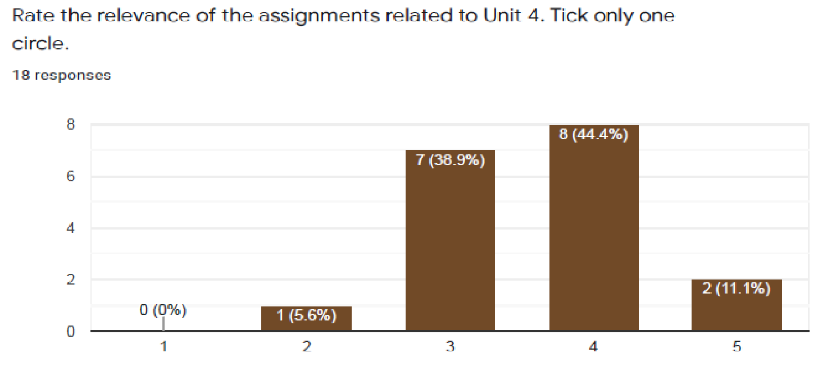

**8. Timing**

Course participants have been asked *“Was the amount of time it took to complete Unit 3 appropriate? Why or why not?”*

Similar to Unit 1, 2 and 3 – students said that it took too long to complete Unit 4.

Still students were appreciative that a new time frame was introduced.

Some said that it was better than Unit 3 but a lot of issues were experienced in relation to organization of practical sessions which was difficult because it was dependent on availability of other people. All the units so far take much longer than is set out in the pro forma given, and this can be challenging.

There was disappointment that some students did not have enough time to complete this unit and as a result they had to request that the practice sessions be discarded.

Other found the time needed more than they could afford:

*“I don't feel that the time was enough. The practice and preparation time required for the practical assignments took quite a bit of time. It also required us to meet many times as a group to record them and in the case of the meeting assignment we had to prepare our own facilitation and prepare for the roles of the other group members.The assignments were on average 2.5 hours of recording per assignment.”*

*“The course is really time consuming and I have given up checking the times because it always takes longer. It is also very interesting fortunately.”*

*no, the practical assessments are hard to organize across countries*

*“Took an inappropriate amount of time because of difficulties in organising a group of people to be available at the same time. “*

*“The whole content could have been done in half the amount of sections, it was absolutely too repetitive, to the point of being almost painful to go through...”*

*“Reading materials (even though relevant) they were way too much time consuming. It is much more effective and practical in terms of learning and understanding watching the educative videos. When is about the theorical part of assessments it would be much more shorter time, relevant, practical and objective grading if used the "true/false" type questions, or "fill in" or "choose the right answer/s" . Another time consuming were some of the Learning Journal questions, which I found irrelevant. “*

*“We needed a lot more time than predicted. I would say that this is the main issue for this course. And a lot of work is expected, for this level. “*

*“Too time consuming, too many things to turn in and too many extra zoom meetings with instructors without the time being taken away in the course, one could've cut out the learning journals.”*

*“It was a difficult unit to finish in the time scale, the readings are very heavy and it was difficult to get the peer group together to complete practical assignments. Some of the assignment were unnecessary or repetitive.”*

**Platform Design**

**9. Understanding the Moodle Platform**

Students were asked *“What was the easiest part about navigating/using Moodle? You can check as many answers as appropriate?”*. Answers included: navigating inside the Learning content (22.2%), logging in (11.1%), downloading documents (11.1%), using the Learning journal (22,2%), finding the course (11.1%) and other features.

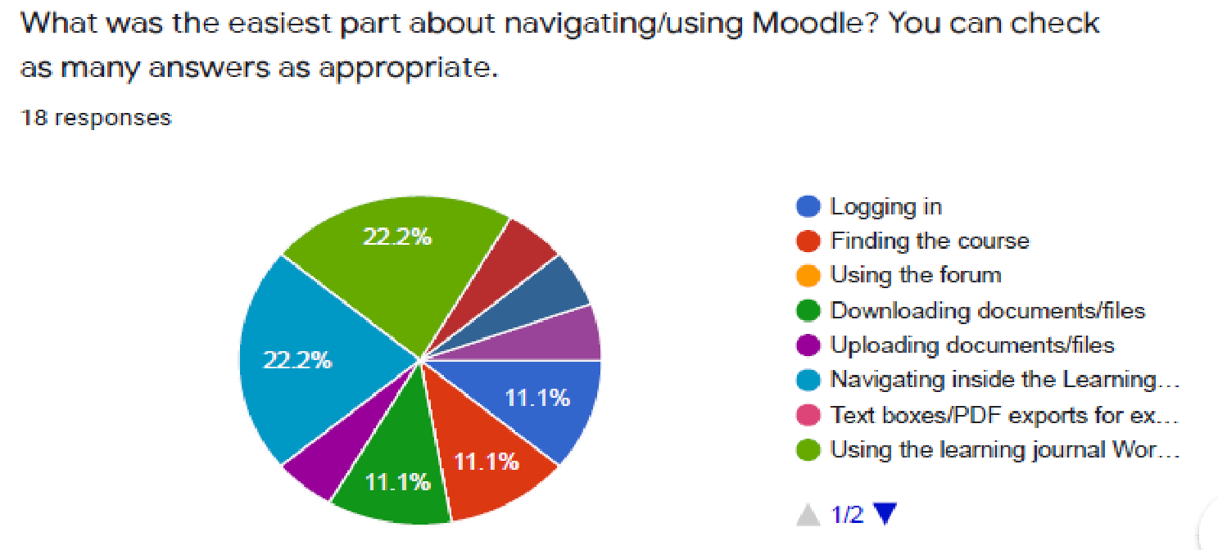

The question *“What was the hardest part about navigating/using Moodle? You can check as many answers as appropriate?”* It can be seen that for some students’ difficulties came from features that were easy for others. Some students found difficulty in navigating inside the Learning content (16.7%); logging in (16.7%); downloading documents (16.7%); or uploading documents (11.1%).

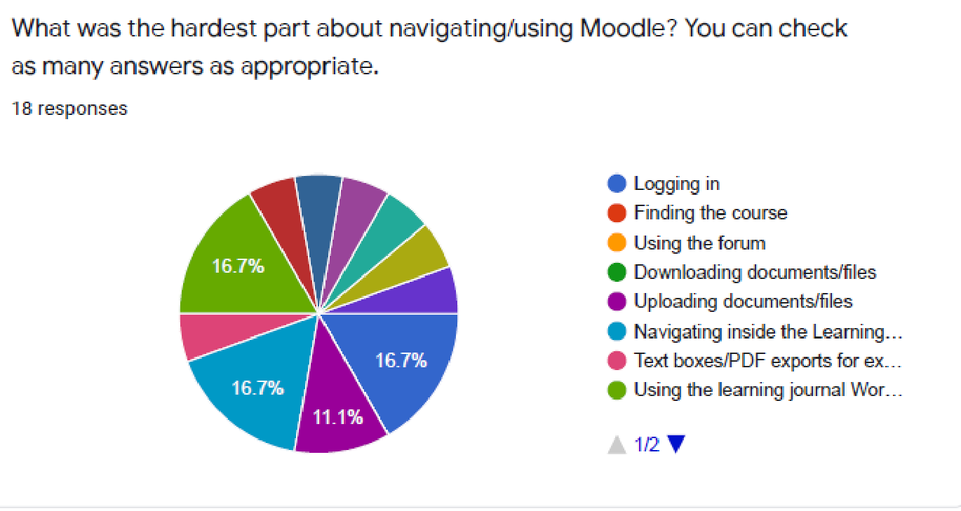

**10. Visual Design**

When asked to rate the overall visual design, including the images and graphics used in Unit 4, 38.9% (7) of learners rated it as completely satisfactory; 50.0% - as satisfactory; 5.6% (1) person had rated their answer in the middle between unsatisfactory and completely satisfactory and one person found the visual design rather unsatisfactory.

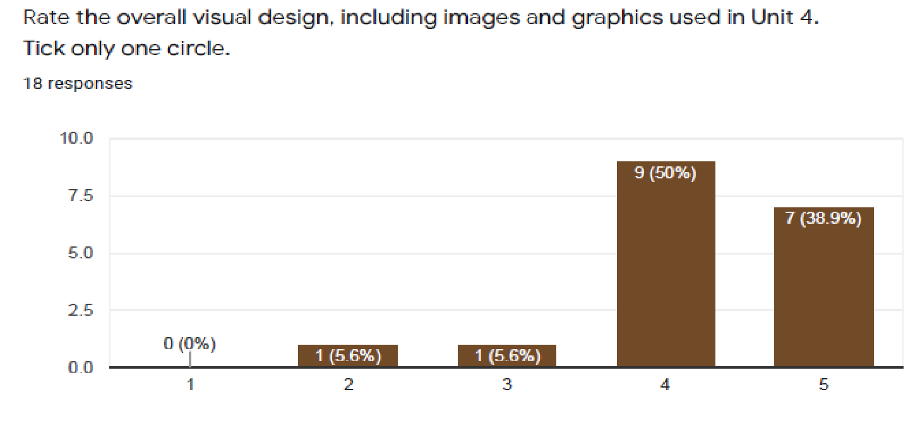

**11. Quality of Audio-Visual Materials**

Most participants in the course evaluated the quality of video and audio materials as being of excellent quality (44.4%, 8 students) and good quality (27.8%, 5 students). 4 learners /22.2%/ circled the middle answer - that the quality is neither good, nor bad and one student (5.6%) declared rather bad quality of video and audio materials. The results are very similar to those of previous Modules.

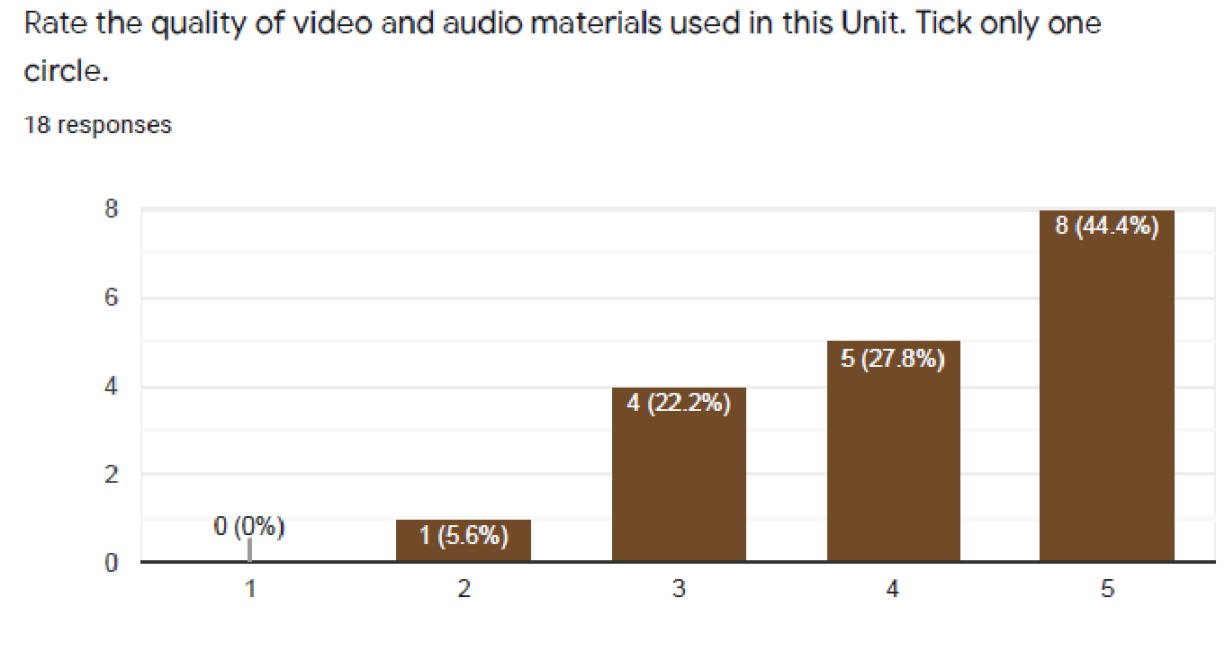

**12. Most Useful Way to Learn the Moodle Platform**

Learners have been asked *“What would be the most useful way for you to have learned how to navigate the Moodle platform?”.* Most students preferred to have a short video showing the basics (11 students, 61.1%) and the other part of the group showed that an infographic (a page with screenshots and short explanations) would be a good way to learn the platform (7, 38.9%).

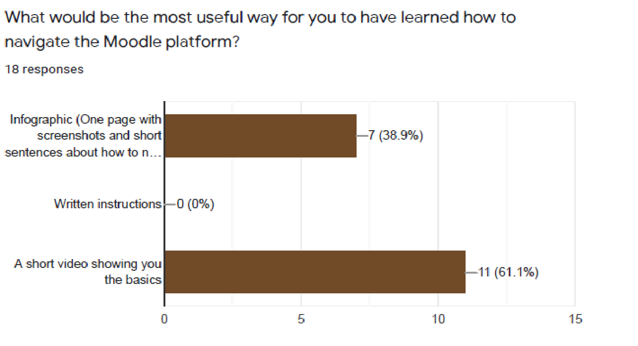

**13. Tutorials**

The question *“Was the Unit 4 Zoom Tutorial with the Tutors from CDI useful to you? Why or Why not?”* has got 18 responses and most answered in a very positive way.

People found it useful that tutorials provided clarification and help for practical sessions.

*“Yes, Clare and Andy were flexible in fulfilling our requests for more support for the practical assignments and answered our questions.”*

*“Claire and Andy are absolutely helpful and engaged in this course. I wish we could have at least once a week zoom tutorials. Would have helped a lot with clarifying topics, aspects, clear up confusion, practice more and going through units together as class and tutors. Socializing via zoom was also very very positive.”*

*“Excellent, It is the most valuable part of the course.”*

Some recommendations about the organization of tutorials were also offered:

* Demonstrations by tutors

*“Claire and Andy are great but I would have loved multiple role plays of circles, meetings and conferences by them demonstrating because this is new to me.”*

* More structure and focus on unit content

*“I find aspects of the tutorial useful. I would rather they are more structured and focused on the unit content.”*

* Less repetition

*“Lots of repetition….”*

* Better organization of the meeting.

**14. What did you like most about the Unit 4 Zoom Tutorial with the Tutors from CDI?**

Students liked the tutorial because it helped clarify, helped understand concepts, guiding through practice processes getting feedback and answers. Students got support from tutors and peers, had opportunities to ask questions, and to connect with others. Demonstration in the role play by tutors was especially appreciated.

Tutorials helped some students to get motivation to continue the course. It also brought joy by providing connection, sharing and mutual support during the learning process.

*“It clarifies issues and motivates me to continue.”*

*“I enjoy being with other students, checking in and sharing experiences of the course.”*

**15. What did you like least about the Unit 4 Zoom Tutorial with the Tutors from CDI?**

Many students did not have any dislikes to share and answered “not applicable”.

Some had technical problems such as “*drop out fairly often and the time delay when speaking*”. One said that the connection was not good and could not hear well.

Others were not happy that the tutorials were often spent discussing issues arising which could *“lead to quite negative discussions”* and *“cuts from the time of the actual tutorial”*.

Some students would love to have more tutorials and more demonstrations of scenarios.

One student said that their questions were not answered, and clarity was not achieved.

**16. Overall Satisfaction**

The overall feedback about Unit 4 was rather positive: rather satisfied declared 55.6 % (10) of participants and very satisfied only 3 or 16.7%. Another, 16.7% (3) were neither satisfied, nor dissatisfied; there were two students (11.1%) who declared that they were rated dissatisfied. 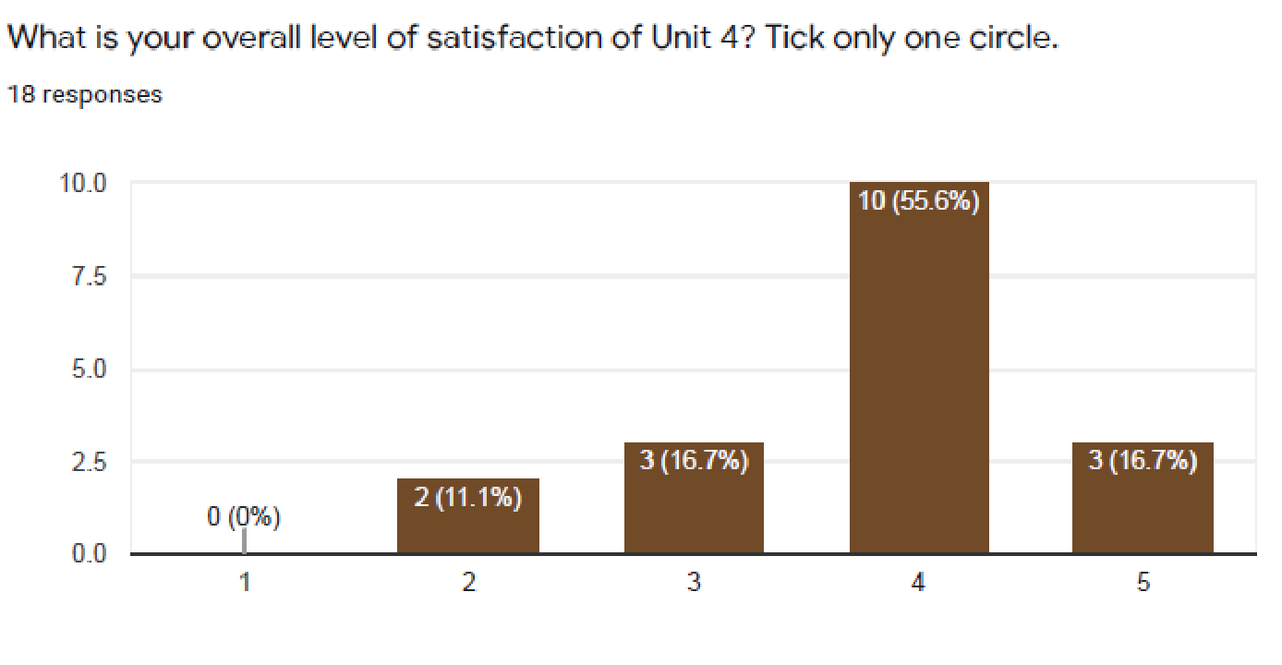

**Conclusions – Unit 4**

With the course approaching its end it can be said that most students found it useful and inspiring. Despite some issues during the process 18 students clearly made progress in their learning and acquired knowledge and skills in the area of restorative practice.

The persistent concerns and issues which were not resolved seemed to be related to Moodle navigation, the time needed to complete the course and the content overload.

Specific recommendations for improvement of the course and increase of students’ satisfaction were given in the following areas:

* Students need to have an available “support mechanism” which they can rely on at any point in their learning process.
* Timing of the course and the amount of work need to be revised and made more efficient.
* It is important to reduce the amount of repetitions during the course and optimise the course content.
* Course design could benefit from some improvements in terms of simplifying it, improve quality of video and audio materials and reduce navigation difficulties. Students would benefit from pre-course training on how to navigate Moodle platform by video instruction or Infographics.
* Assignments have to be optimised and perhaps reduced in terms of length and frequency. At the same time practical sessions are appreciated and benefit a lot by tutorials which provide clarity, guidance and support.

**Unit 5**

**1. Understanding the Content**

Participants have been asked to rate their understanding of contents of Unit 5 using a scale from 1 (did not understand at all) to 5 (completely understood). The results show that 8 completely understood (53,3 %) the content of the course, 3 students understood it (20%) and 4 (26,7 put their level of their understanding of the content in the middle between the extreme points. It seems that more students than in the previous module had some issues in understanding this Module 5.

In Module 4 only one person was in the middle of the scale between completely understood and did not understand at all. In both Modules 4 and 5, no one said that they had difficulties in understanding the content.

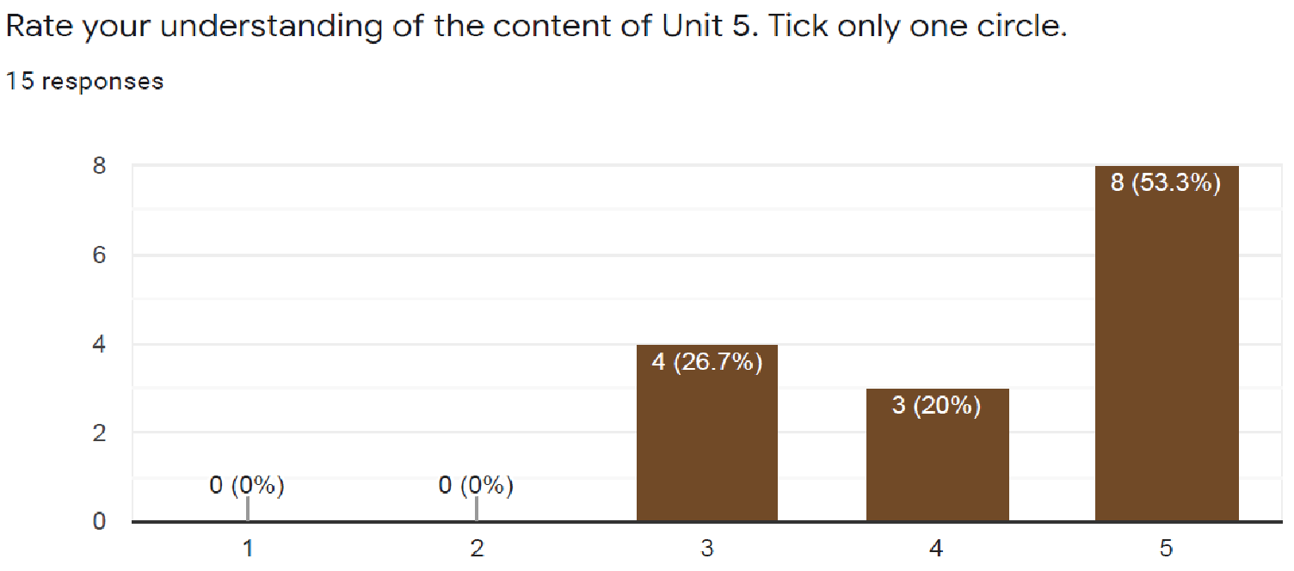

**2. Consistency and Relevance**

Participants used a scale to assess the consistency and relevance of the course - from 1 not consistent and relevant at all to 5 completely consistent and relevant. 33.3% (5 students) reported that they found the material completely consistent and relevant; 33.3%, 5 students found the material rather consistent and relevant; 20% (3 learners) found the material in the middle of the extreme points. There were 2 students pointing out that the content was rather inconsistent. This is another difference from the evaluation of module 4 where negative evaluation of consistency and relevance was not registered. It seems that the organisation of the content of this module was more challenging for learners.

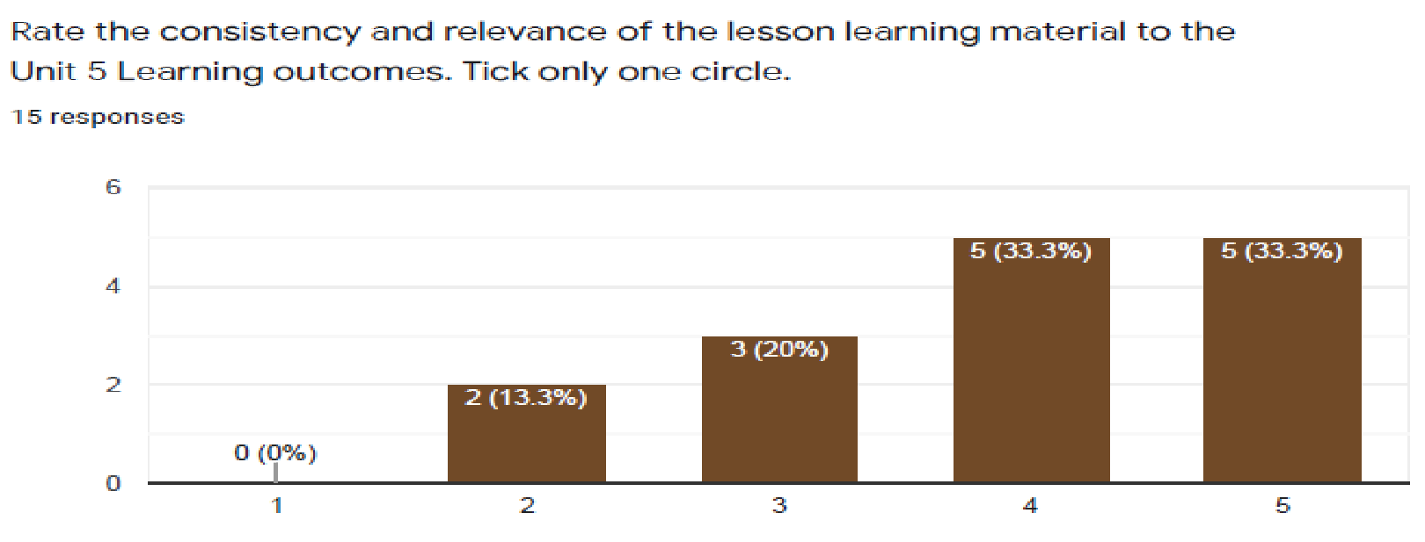

**3. Quality of the Content and the Examples Presented**

Learners’ opinions about the quality of content of Unit 5 is rather positive for 10 students (66,7%). Only 2 students reported excellent quality though – 13,3%, neither excellent, not poor was the opinion of 1 student (6,7%) while 2 students (13,3%) were rather negative to the content and examples presented.

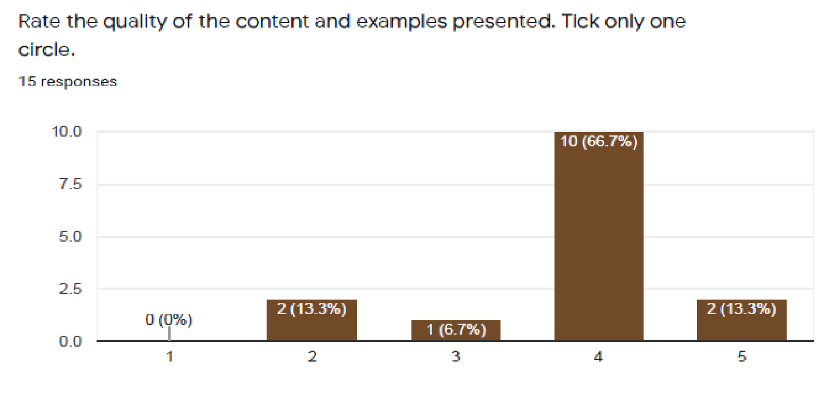

**4. Most Useful and Interesting Parts of Unit 5**

Students were asked *“What part of Unit 5 did you find most useful and interesting?”*. 15 students responded. The following areas were underlined as very useful:

* RJ and the relevant international laws that support its development
* The Culture of Restorative Organisations and the implementation of RP into Organisations
* The information on how to implement and present RP within an organisation and how to embed RP into the culture of an organisation.
* Implementation Plan of RP into organisations/ workplace
* The case studies
* Sustaining the RP approach

**5. Least Useful and Interesting Parts of Unit 5**

The question *“What part of Unit 5 did you find least useful and interesting?”* received 15 responses. For most students the challenge was the legal background:

*“The extra legal part, whist I understand the importance of them, they are still very tedious to read and understand”.*

*“The Law and Policy section was very heavy reading, each section was very similar in name and the assignments were, as a result, a bit confusing.”*

**6. Clarity and Logic**

The question *“Was the content of Unit 5 arranged in a clear and logical way? Tick only one circle.”* was answered as follows:

Only 3 (20.0 %) of respondents found the content of Unit 5 completely clear and logical. 8 learners 53,3% found the content rather clear and logical. 4 students or 26,7 % perceived the content to be between clear and unclear. There were no students who said that the content was completely unclear.

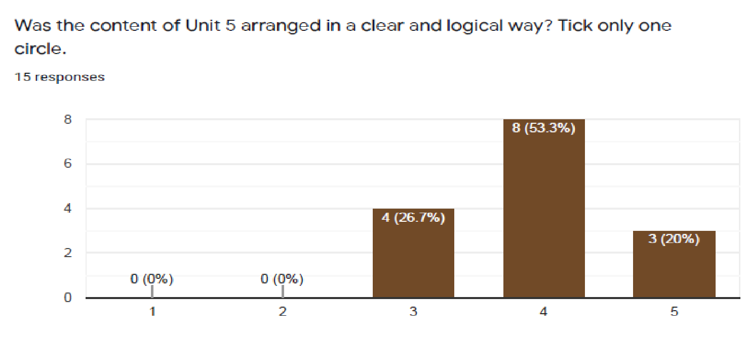

**7. Relevance of Assignments**

Similar to the previous units, many participants who completed Unit 5 found the assignments to be in the middle of completely relevant and completely irrelevant (3 or 20%). Completely positive about the relevance of the assignment were only 2 students (13,3%) and 4 students (26,7%) found the assignments rather relevant.

This module had the bigger group of students who found the assignment rather irrelevant (3 students or 20%) or completely irrelevant – another 3 students (20%).

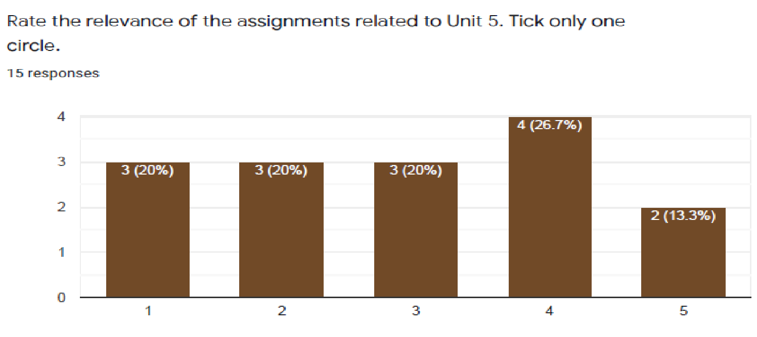

**8. Timing**

Course participants have been asked *“Was the amount of time it took to complete Unit 3 appropriate? Why or why not?”.*

Similar to Unit 1, 2, 3 and 4 – students said that it took too long to complete Unit 4.

Again almost all of them said that the time allocation was inadequate to complete assignments.

*“I spent more than 200 hours on this module.”*

*“The amount of reading material was immense!”*

*“The assignments for Unit 5 related to Law and Policy took quite a long time to complete.”*

*“I would have to say no. I found this unit took much longer than you think. I worked every day without exception, with every Saturday and Sunday being included, from June/July right through until now at the middle of October. I would be spending 8-10 hours each day of the weekend working on the assignments and other parts of the course. I found the main assignments took me many hours to complete. The Learning journals also take a very long time to complete if they were to be done properly. I really put a lot of effort in to these.”*

*“No it is not appropriate. There is plenty of research and reading to be done. It would have been better, for our learning, to have it spread out a bit more. “*

*“No. It took quite a bit of time to get around the legal side and terminology, laws and policies. There were too many vague assignments with a high word count. Spent a lot of time trying to figure out what laws/policies/examples could be used for the assignments”.*

*“The hours mentioned in the description of TREP is not according to the reality. Not only the online spent time on studing the course has to be considered, but all the extra materials, which are vital for undertsanding what we learn, and unnecesary learning journals and assessments with long narative answers etc, what could have been reduced to a “true-false”, “choose the correct answer”. or “fill in” type of answers. That whould have saved us lots of time, energy (mostly energy and frustruation) focus on the unit itself and a more realistic time to study, read, comprehend and understand the unit. Another option could have been to replace reading materials with podcasts or videos, but of course, not in every case would be possible when it comes about laws, policies and recommendations.”*

**Platform Design**

**9. Understanding the Moodle Platform**

Students were asked *“What was the easiest part about navigating/using Moodle? You can check as many answers as appropriate?”*. Most popular answers included: navigating inside the Learning content (20.0%), logging in (20,0%) and downloading documents (13,3%).

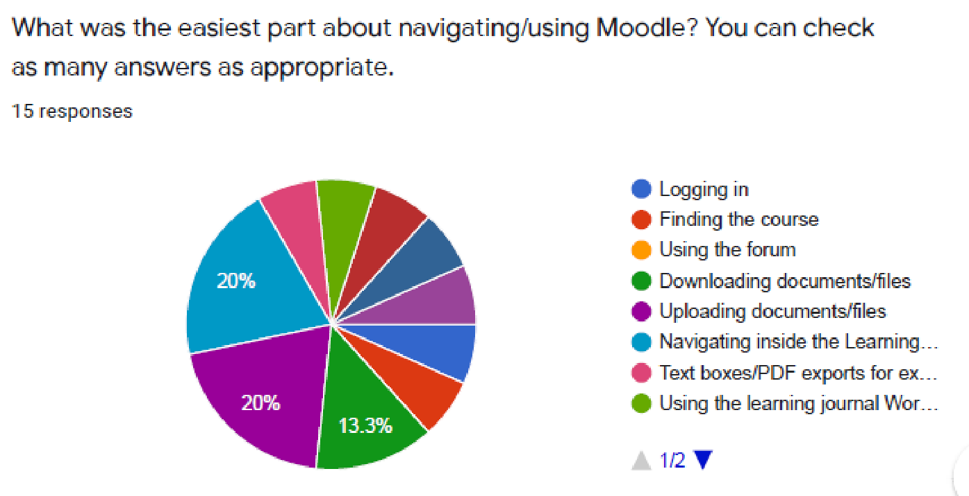

The popular answers for the question *“What was the hardest part about navigating/using Moodle?”* were as follows: navigating inside the learning content (20 %); logging in (20%) and finding the course (13,3).

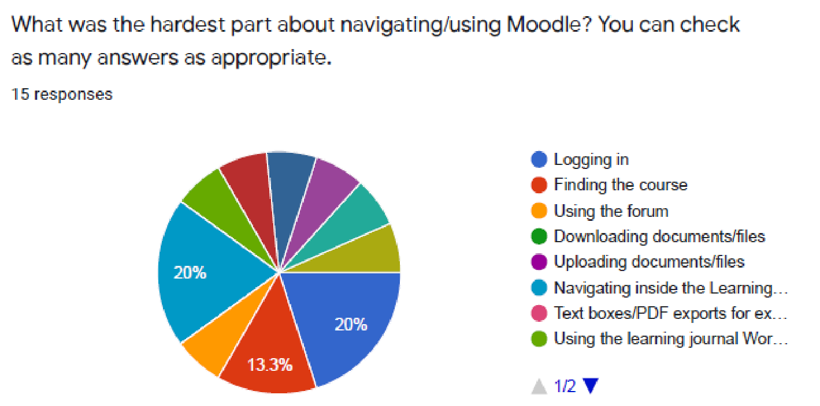

**10. Visual Design**

Regarding the visual design of Unit 5, most learners evaluated it in a positive way. 33,3% (5) of learners rated it as completely satisfactory; 46,7% (7) - as satisfactory; 20% (3 students) had rated their answer in the middle between unsatisfactory and completely satisfactory.

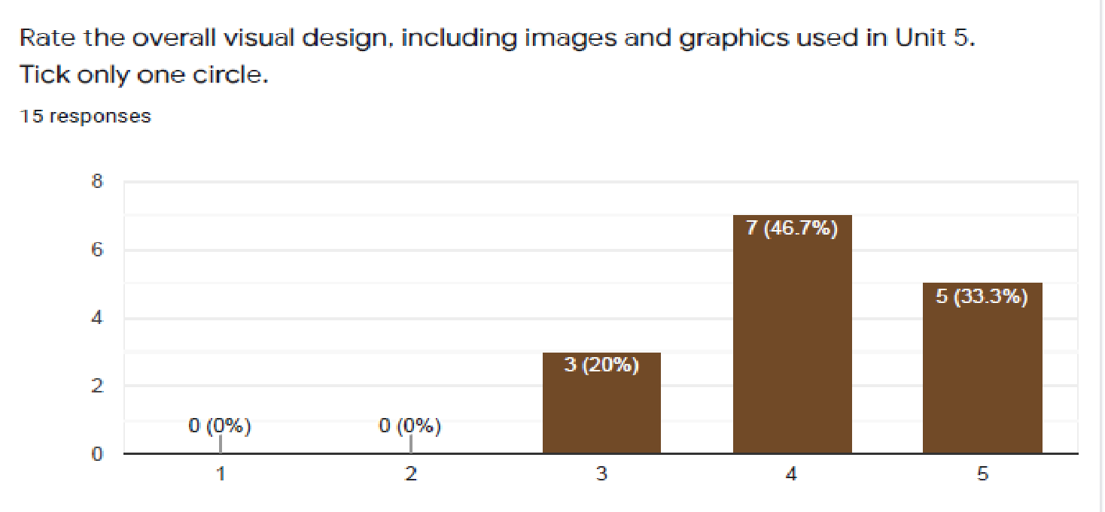

**11. Quality of Audio-Visual Materials**

Most participants in the course evaluated the quality of video and audio materials as being with excellent quality (40%, 6 students) and good quality (40%, 6 students). 3 learners (20%) circled the middle answer - that the quality is neither good, nor bad. The results are very similar to those of previous Modules.

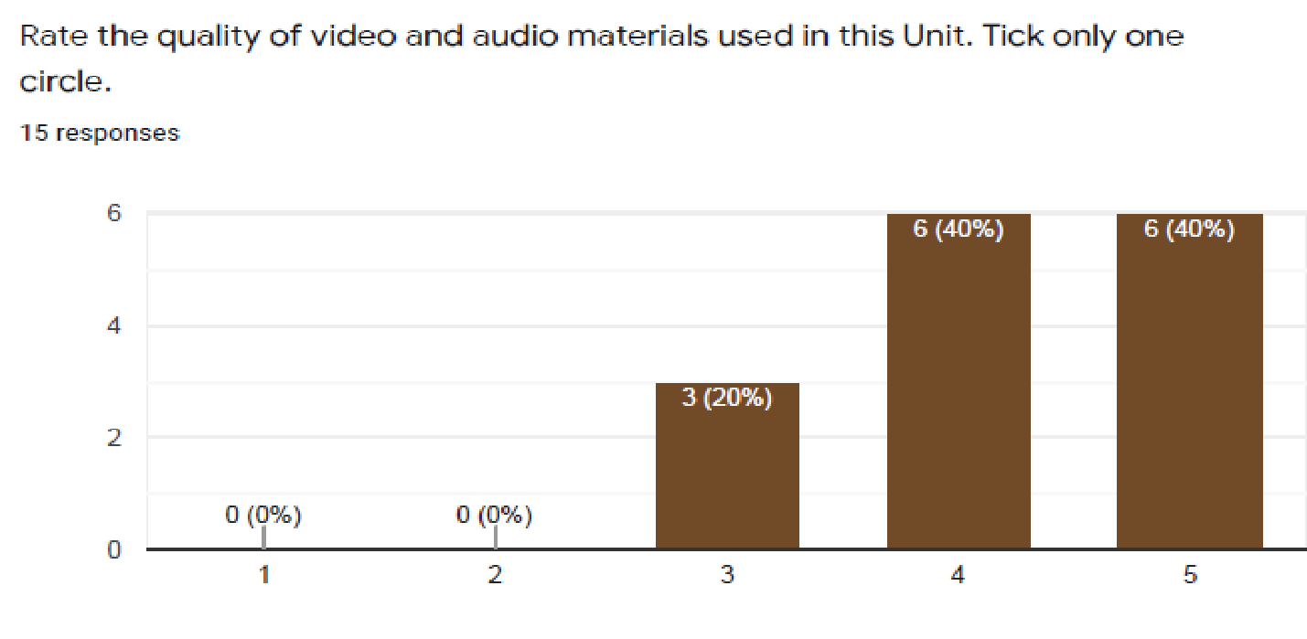

**12. Most Useful Way to Learn the Moodle Platform**

Learners have been asked *“What would be the most useful way for you to have learned how to navigate the Moodle platform?”.* Most students preferred to have a short video showing the basics (14 students, 93,3%) and the other part of the group showed that an infographic (a page with screenshots and short explanations) would be a good way to learn the platform (2 students, 13,3%).

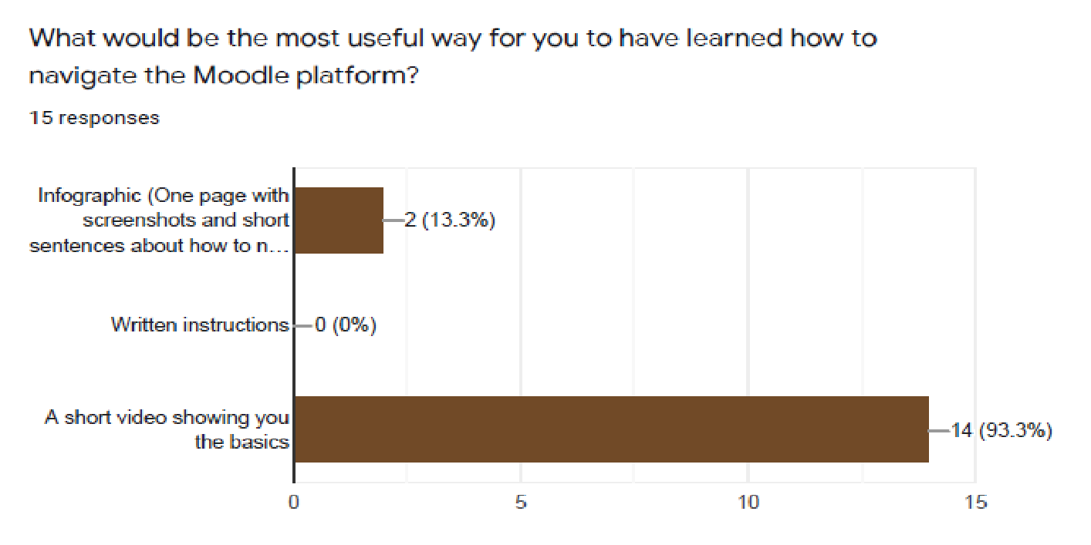

**13. Tutorials**

The question *“Was the Unit 5 Zoom Tutorial with the Tutors from CDI useful to you? Why or Why not?”* has got 15 responses.

Students found the tutorials useful and important. Tutorials provided an opportunity to meet peers, ask questions, exchange views and clarify problems. Tutorials were found useful to discuss ways in which to implement RP into its own practices.

*“Absolutely useful, they kept me going and I wish I could have more tutorial, at least 1 zoom before each assessments, clarifying, explaining and giving an clear view where maybe doubts, questions or unclarified items could have been explained. Great professionals! Thanks to them I could go thorugh this course.”*

**14. What did you like most about the Unit 5 Zoom Tutorial with the Tutors from CDI?**

Students likes meeting peers and tutors, they appreciated the support from Claire and Andy and their peers. In this last module the tutorial gave a chance to thank everyone in the course and say goodbye.

*“The atmosphere was nice!”*

*“It is always a privilege to get together with the tutors and the participants to share our experiences.”*

**15. What did you like least about the Unit 5 Zoom Tutorial with the Tutors from CDI?**

Most students had nothing to share in this part of the questionnaire.

Some shared that they would have liked to have more time to discuss content and assessments. Others said that there was *“not enough time, not enough answers to our questions.”*

A few students said that the tutorials come quite late in the unit which does not provide opportunity to connect with others for support.

**16. Overall Satisfaction**

The overall feedback about Unit 5 was lower in comparison with other units.

Nobody was completely satisfied. “Rather satisfied” declared to be 60 % or 9 participants. 20% (3) were neither satisfied, nor dissatisfied; there were two students (13,3%) who declared that they were rated dissatisfied and one student (6,7%) who circled the answer “completely dissatisfied”.

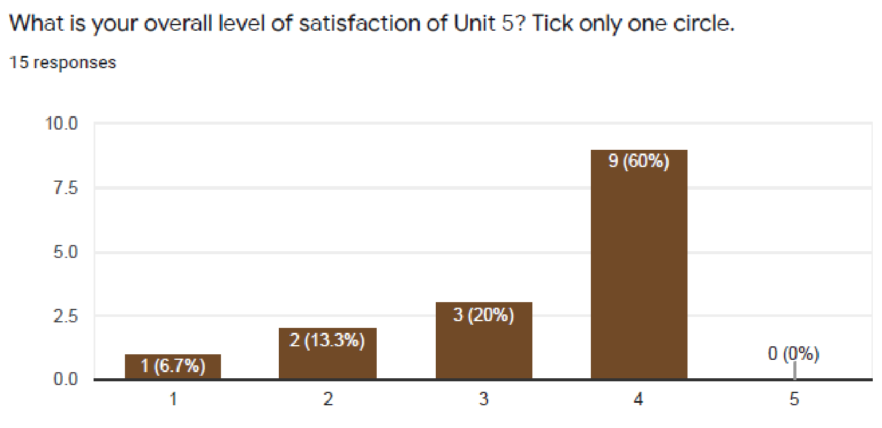

**Conclusion - Unit 5**

The last module of the course seemed to be most challenging for students. Still all the 18 students who completed Module 3 and Module 4 managed to complete Module 5 as well and thus the whole course. These 18 students went through the whole process of learning and acquired deep knowledge about the restorative practices.

Regarding Module 5 there was some confusion related to assessment, e.g. some questions appeared to be not clear for some students. There were strong voices for optimization of assignments and reduction of their length. Tutorials and practical sessions were especially appreciated because they provided support system, sharing and peer exchange.

In conclusion, students shared their feedback about their experience and underlined once again the huge commitment required to complete the course in terms of time and efforts.

This was not very clear for many of them in the beginning.

Students found the content to be excellent but very heavy at times.

*“The course as a whole was overstretched with too much to write and too much time taken on topics that could have been done in less time. The sheer amount of reading is comparable to a degree and not a certificate.”*

The content of the unit was found interesting and students were thankful and appreciative to the course creators, tutors and administrators.

1. Completed the evaluation after the evaluation report was finalized.